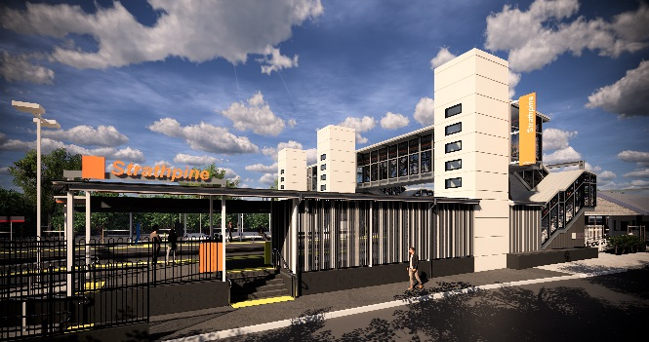
Strathpine station accessibility upgrade

WORKS NOTICE

Night and weekend works – scheduled track closure
4am Saturday 6 to 1am Monday 8 April 2019

As part of the Strathpine station accessibility upgrade, continuous works will be undertaken at the station from 4am Saturday 6 to 1am Monday 8 April 2019.
These works will be undertaken during a scheduled track closure, when there is no rail traffic and the overhead power is switched off. During this time, rail replacement buses will operate from Station Street (opposite the library).
The western carpark will be closed, but pedestrian access through the carpark to the temporary stair-only footbridge and South Pine Road level crossing will be maintained. Whenever it is safe to do so, the temporary footbridge will be open for cross-corridor pedestrian access.
Please follow directional signage and take care around the work zones.
Residents near the station may experience some noise associated with construction activity and truck movements. Mobile lighting towers will be used, as required, during night works.

Scheduled night/weekend work
Queensland Rail Limited ABN 71 132 181 090
Location | Dates and hours of work | Type of work
Strathpine station  Western carpark (closed) | 4am Saturday 6 to 1am Monday 8 April  (continuous works) | Station upgrade works involving:  - excavation on platform 2/3  - concrete pour (footings) – platform 2/3 and western carpark  - heavy machinery and trucks with flashing lights and reversing beepers  - hand-held tools and powered equipment  - movement of personnel and vehicles around the station precinct  - portable lighting towers at night.
Every effort will be made to minimise disruption and we apologise for any inconvenience as we work to improve your station.
The Strathpine station accessibility upgrade is part of Queensland Rail’s $300 million program to upgrade stations across the South East Queensland network, making them accessible for all customers. For more information about the accessibility upgrade, please contact the project’s community team during business hours on 1800 722 203 (free call) or email stationsupgrade@qr.com.au

We are moving towards paperless notifications about noise and works. You will still see paper notices as we transition to the new system. Sign up at queenslandrail.com.au/EmailNotification or contact us if you prefer to receive paper copies.

