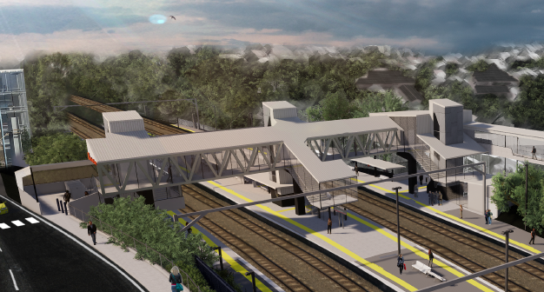
Auchenflower station accessibility upgrade

WORKS NOTICE

Night works – overhead line infrastructure
March 2020

In preparation for the Auchenflower station accessibility upgrade, overhead line infrastructure works will continue on additional nights in March, between 9pm and 5am the next day (weather and construction conditions permitting). For the safety of workers and the public, these works have been scheduled after hours, when there is reduced rail traffic and the overhead power is switched off.
These activities are a continuation of works commenced on Sunday 22 March and we apologise for the limited notification period for these additional nights due to late scheduling.
Residents near the station may experience some noise associated with construction activity and the operation of cranes and truck movements around the work zone. Every effort will be made to minimise disruption.

Overview of night works
Queensland Rail Limited ABN 71 132 181 090
Location | Dates and hours of work | Type of work
Auchenflower station and rail corridor  Rail corridor access gates (near Dixon Street, Auchenflower Terrace and Eagle Terrace/Cue Street) | From 9pm to 5am the next day on:  - Monday 23 March  - Thursday 26 March | Overhead infrastructure works involving:  - crane operation  - electrical works  - operation of machinery and trucks with flashing lights and reversing beepers  - hand-held tools and powered equipment  - movement of personnel and vehicles around the station and in the rail corridor  - portable lighting towers at night.
The Auchenflower station accessibility upgrade is part of the State Government’s $357 million investment to upgrade stations across the South East Queensland network, making them accessible for all customers.
For more information, please contact the project’s community team on free call 1800 722 203 or email stationsupgrade@qr.com.au

We are moving towards paperless notifications about noise and works. You will still see paper notices as we transition to the new system. Sign up at queenslandrail.com.au/EmailNotification or contact us if you prefer to receive paper copies.

