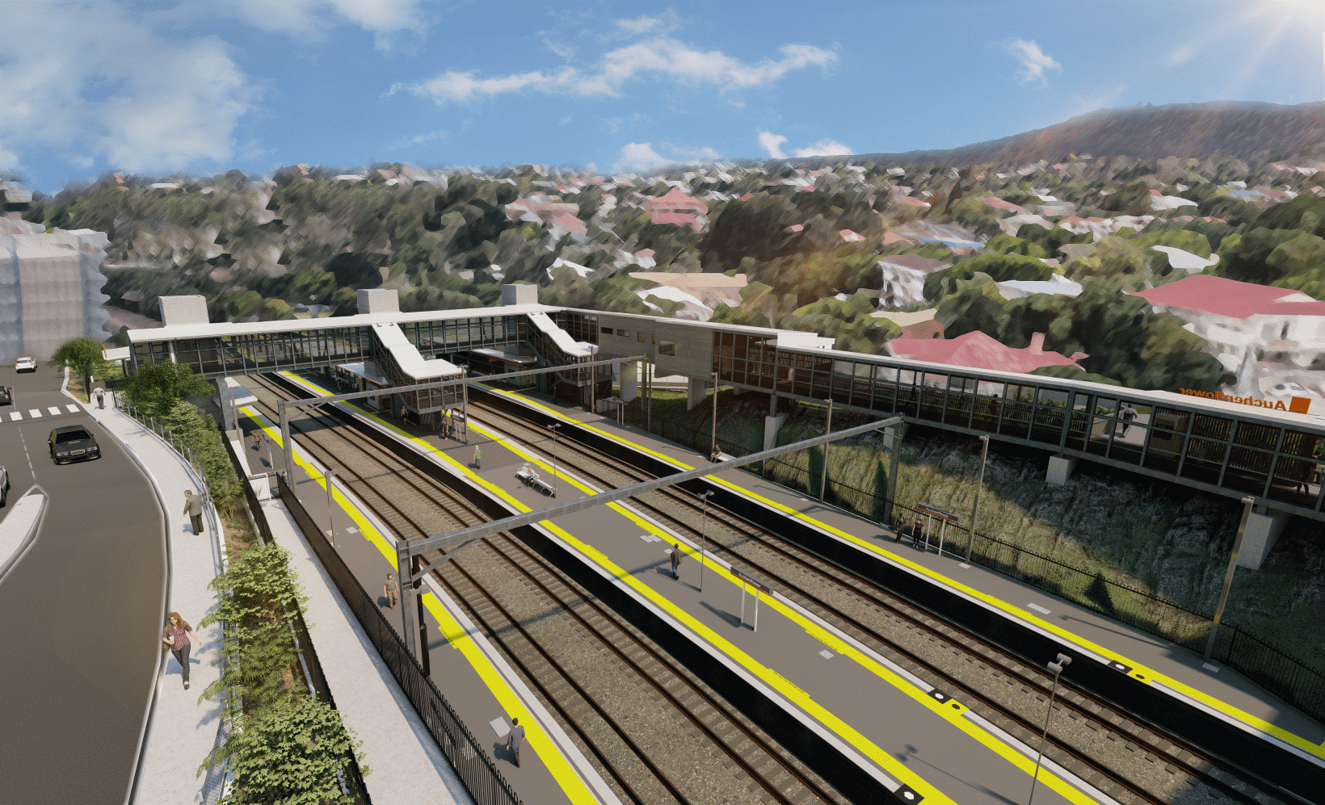
Auchenflower station accessibility upgrade

WORKS NOTICE

After hours works
Late March/early April 2022

As part of the Auchenflower station accessibility upgrade, Queensland Rail will undertake night and after hours weekend works on selected dates in late March and early April.
For safety, these works can only be undertaken after hours when rail traffic is reduced and there are fewer people around the station precinct.
Demolition of the old station building in the station carpark will continue and demobilisation of the large crane will commence from Friday 25 March.
Traffic management may be required to support site access and other construction activities. Auchenflower Terrace is currently closed for construction works until 6pm Saturday 2 April. Motorists are advised to follow the instructions of the traffic controllers and drive to the changed conditions.
Residents near the station may experience noise associated with trucks movements and construction activity around the work zone. Every effort will be made to minimise disruption and we thank you for your patience during these important works.

Overview of works (weather and construction conditions permitting)
Queensland Rail Limited ABN 71 132 181 090
Location | Dates and hours of work | Type of work
Auchenflower station, carpark and rail corridor  Surrounding local streets (Auchenflower Terrace, Ridley Street, Eagle Terrace, Lang Parade) | Selected night works, 6pm to 6am the next day on:  - Friday 25 March  - Saturday 26 and Sunday 27 March  - Monday 28 March to Friday 1 April  - Saturday 2 and Sunday 3 April  - Monday 4 to Friday 8 April  - Saturday 9 and Sunday 10 April  - Tuesday 12 April.  (over 18 separate nights)  Note: Sundays listed above will also include day shifts 6.30am to 6.30pm. | Station upgrade activities involving:  - demolition of old station building  - demobilisation of large crane  - installation of a piling pad (earthworks) – Lang Parade side  - piling bridge foundations (truck-mounted piling rig)  - paving (platforms)  - concrete pumping and concrete works  - roadworks and linemarking (pedestrian crossing, Lang Parade)  - operation of machinery and heavy equipment  - the movement of vehicles and machinery with flashing lights and reversing beepers  - use of hand-held tools and powered equipment  - portable lighting towers in use at night  - road closure (Auchenflower Terrace), lane closures (Lang Parade) with traffic management (as required).
The Auchenflower station accessibility upgrade is part of the State Government’s ongoing investment of more than $500 million to upgrade stations across the South East Queensland network, making them accessible for all customers. For more information, please contact the project’s community team on free call 1800 722 203 or email stationsupgrade@qr.com.au
Sign up for electronic notifications at queenslandrail.com.au/EmailNotification

