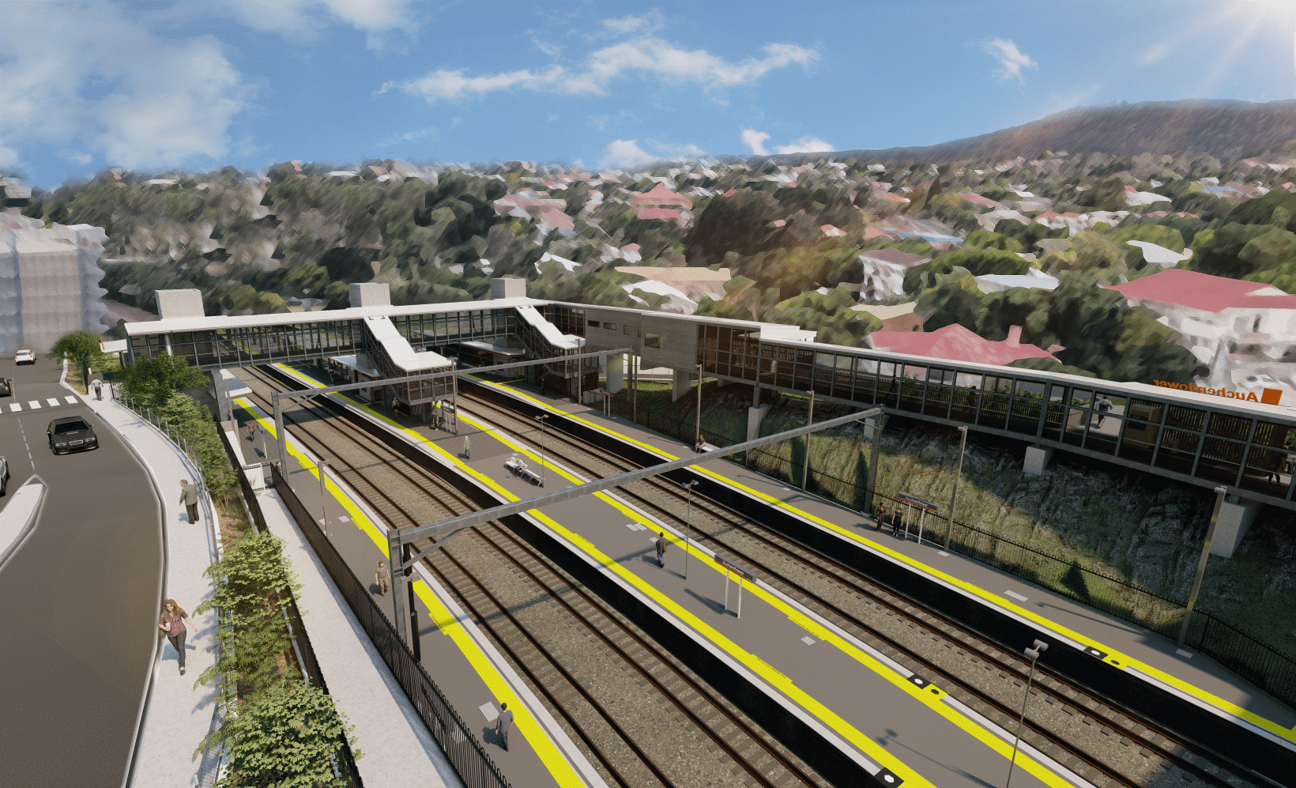
Auchenflower station accessibility upgrade

WORKS NOTICE

Asbestos removal activities – Auchenflower Terrace work zone
From Wednesday 29 September 2021

As part of the Auchenflower station accessibility upgrade, asbestos removal works will be undertaken from Wednesday 29 September (between 7am and 4pm daily) for approximately one week, weather and construction conditions permitting.
Works will include the removal of contaminated soil (excavated fill containing asbestos material).
Safety is Queensland Rail’s number one priority. There is no risk to public safety from the removal and disposal of the asbestos material.
All works will be managed by a licensed asbestos removal contractor, Rosenlund Contractors (WHSQ Prescribed Activity Licence #2319872). An independent sub-contractor hygienist will perform the associated air monitoring, inspections and confirmation of asbestos removal works.
All national and state Occupational Health and Safety controls will be complied with and validated by a Queensland Rail representative on-site.
Auchenflower station will remain operational and services will not be affected. An exclusion zone will be in place and asbestos material will be removed from site under the supervision of a licensed Asbestos Supervisor (A & B Class).
For more information about the asbestos removal activities, please contact Rosenlund Contractors on (07) 3260 6155.
The current full road closure on Auchenflower Terrace, between Dixon Street and Ridley Street, will be in place until Friday 29 October 2021. Pedestrian access will be maintained on Auchenflower Terrace.
Queensland Rail Limited ABN 71 132 181 090
Residents near the station may experience some noise associated with construction activity and the operation of trucks and heavy equipment around the work zone.
Every effort will be made to minimise disruption and we thank you for your understanding during these important works.
The Auchenflower station accessibility upgrade is part of the State Government’s ongoing investment of more than $500 million to upgrade stations across the South East Queensland network, making them accessible for all customers.
For more information about the accessibility upgrade, please contact Queensland Rail’s community team on free call 1800 722 203 or email stationsupgrade@qr.com.au

Sign up for electronic notifications at queenslandrail.com.au/EmailNotification

