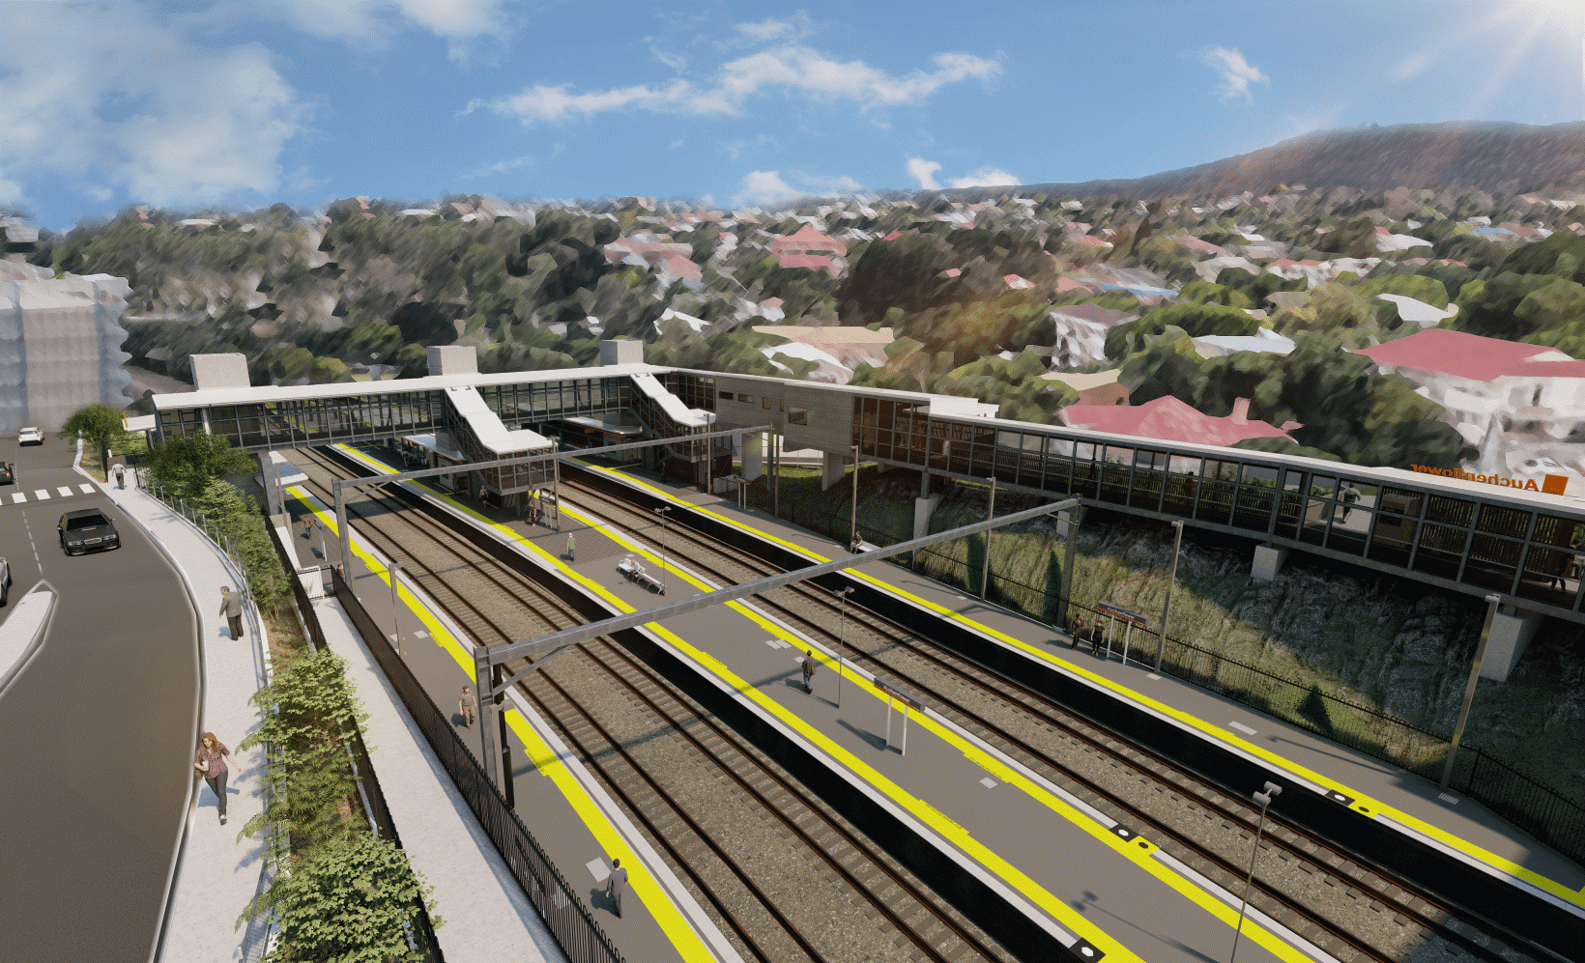
Auchenflower station accessibility upgrade

WORKS NOTICE

Full road closure (extended) – Auchenflower Terrace
To Wednesday 22 December 2021

To support major construction activities for the Auchenflower station accessibility upgrade, the full closure of Auchenflower Terrace (between Dixon Street and Ridley Street) has been extended to Wednesday 22 December 2021 (weather and construction conditions permitting).
This extension to the road closure is necessary due to ground conditions and recent adverse weather events.
During the road closure, the traffic diversion via Milton Road will remain in operation (see map over the page).
Access to private property will be maintained at the instruction of the traffic controller.
Motorists are requested to follow the instructions of the traffic controllers and drive to the changed traffic conditions.
Pedestrian access on Auchenflower Terrace will be maintained on the residential (or western) side of the street.
Residents along the detour route and near the work zone may experience noise associated with an increase in traffic, construction activity and the operation of excavators, cranes, concrete pumping trucks and other equipment.
Large cranes will be positioned in Auchenflower Terrace for the installation of the station’s new footbridge and walkway infrastructure. These activities are an important step in project delivery.
Every effort will be made to minimise disruption and we apologise for any inconvenience as we undertake these important works.
The Auchenflower station accessibility upgrade is part of the State Government’s ongoing investment of more than $500 million to upgrade stations across the South East Queensland network, making them accessible for all customers.
Queensland Rail Limited ABN 71 132 181 090
For traffic management enquiries, please contact John Holland Group’s on-site representative on telephone 0409 271 836.
For more information about the accessibility upgrade, please contact the project’s community team on free call 1800 722 203 or email stationsupgrade@qr.com.au

Sign up for electronic notifications at queenslandrail.com.au/EmailNotification

Page 2.

Full road closure (extended) – Auchenflower Terrace
To Wednesday 22 December 2021
Queensland Rail Limited ABN 71 132 181 090
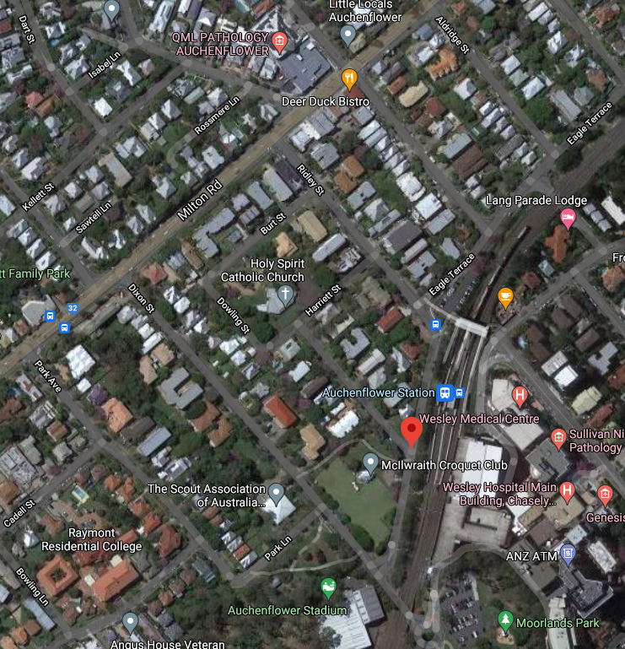

Grimes St

Lang Parade

ROAD CLOSED – EXT TO 22 DEC

Traffic diversion northbound

Road closed – Auchenflower Terrace
extended to 22 December 2021

Map data © Google, 2021

Traffic diversion southbound

ROAD CLOSED

For more information, please contact the project’s community team on free call 1800 722 203 or email stationsupgrade@qr.com.au

