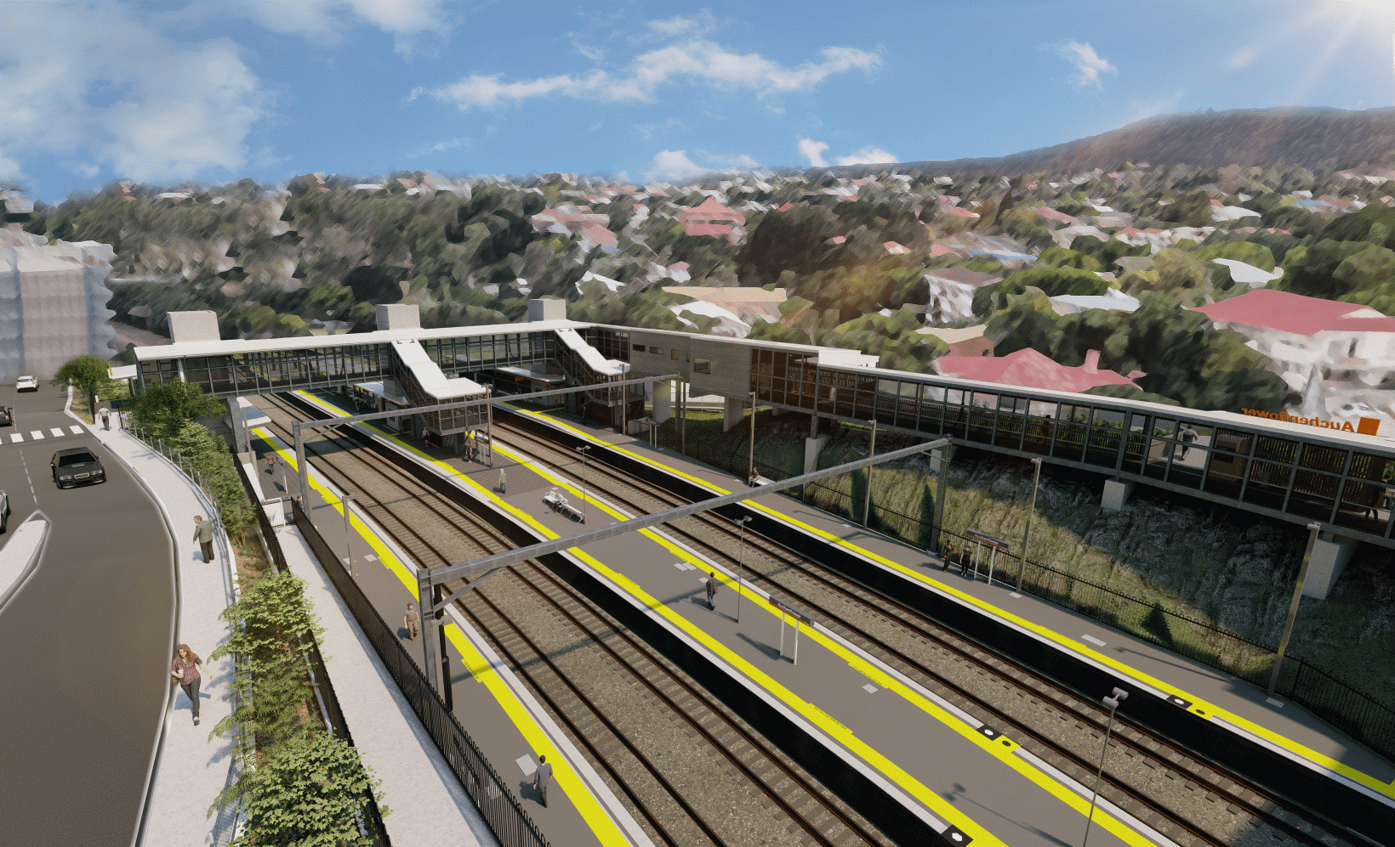
Auchenflower station accessibility upgrade

WORKS NOTICE

Extended full road closure – Auchenflower Terrace
Monday 28 June to Friday 29 October 2021

To support major construction activities for the Auchenflower station accessibility upgrade, Auchenflower Terrace will be closed, between Dixon Street and Ridley Street, from Monday 28 June until Friday 29 October 2021 (weather and construction conditions permitting).
During this extended closure, a traffic diversion will be in place via Milton Road (see map over the page).
Access to private property will be maintained at the instruction of the traffic controller.
Motorists are requested to follow the instructions of the traffic controllers and drive to the changed traffic conditions.
Pedestrian access on Auchenflower Terrace will be maintained on the residential (or western) side of the street.
This road closure will enable the on-site assembly of the station’s new footbridge and walkway as well as the positioning of large cranes for bridge installation. These activities are an important step in project delivery.
Residents along the detour route and near the work zone may experience noise associated with an increase in traffic, construction activity and the operation of excavators, cranes, concrete pumping trucks and other equipment.
Queensland Rail Limited ABN 71 132 181 090
Every effort will be made to minimise disruption and we apologise for any inconvenience as we undertake these important works.
The Auchenflower station accessibility upgrade is part of the State Government’s ongoing investment of more than $500 million to upgrade stations across the South East Queensland network, making them accessible for all customers.
For more information, please contact the project’s community team on free call 1800 722 203 or email stationsupgrade@qr.com.au

Page 2.

Extended full road closure – Auchenflower Terrace
Monday 28 June to Friday 29 October 2021
Queensland Rail Limited ABN 71 132 181 090
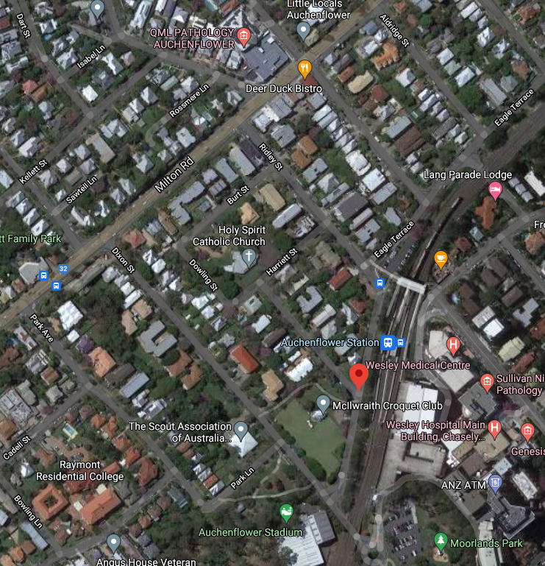

Grimes St

Lang Parade

ROAD CLOSED – 28 JUN TO 29 OCT

Traffic diversion northbound

Road closed – Auchenflower Terrace
28 June to 29 October 2021

Map data © Google, 2021

Traffic diversion southbound

ROAD CLOSED

For more information, please contact the project’s community team on free call 1800 722 203 or email stationsupgrade@qr.com.au

