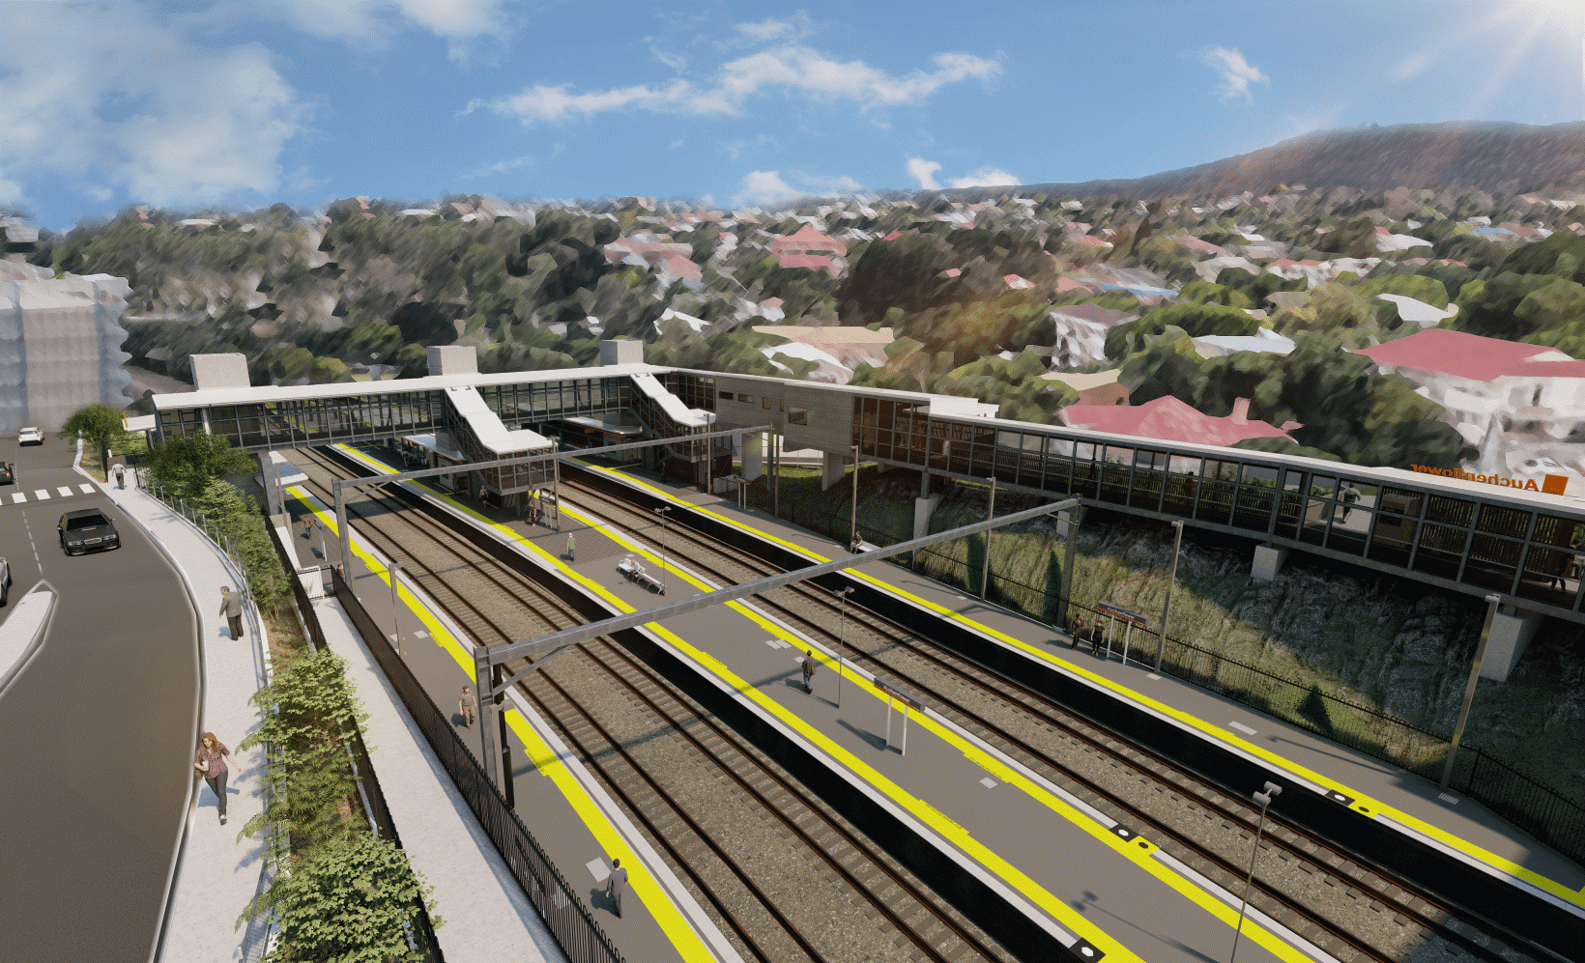
Auchenflower station accessibility upgrade

WORKS NOTICE

Wesley Hospital carpark access changes – Lang Parade closure
- 8pm Friday 25 to 6am Monday 28 February 2022
- 8pm Friday 4 to 6am Monday 7 March 2022

To support major construction activities for the Auchenflower station accessibility upgrade, Lang Parade will be closed (corner Chasely Street) for works on these weekends. All access to The Wesley Hospital public carpark will be via Patrick Lane (see map below).
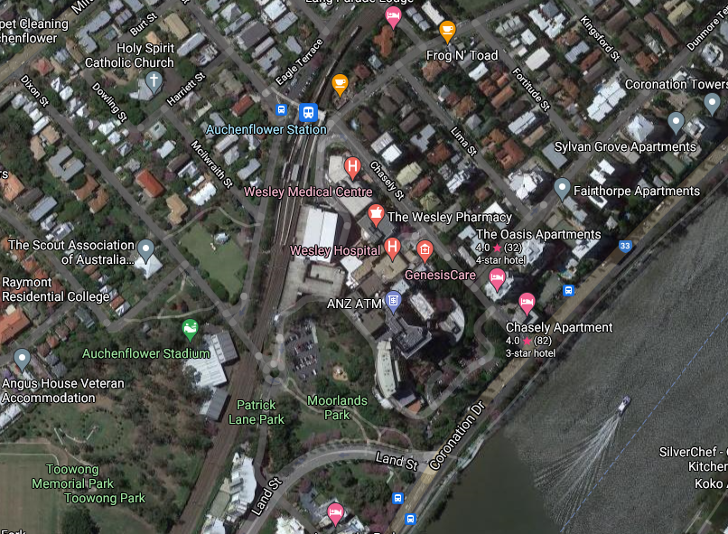
We apologise for any inconvenience as we undertake these important works.

Lang Pde

Auchenflower Tce

Queensland Rail Limited ABN 71 132 181 090
Patrick Ln

Wesley Hospital carpark entry

Map data © Google, 2022

Access to The Wesley Hospital carpark

Lang Parade closed

ROAD CLOSED

For more information, please contact the project’s community team on free call 1800 722 203 or email stationsupgrade@qr.com.au

