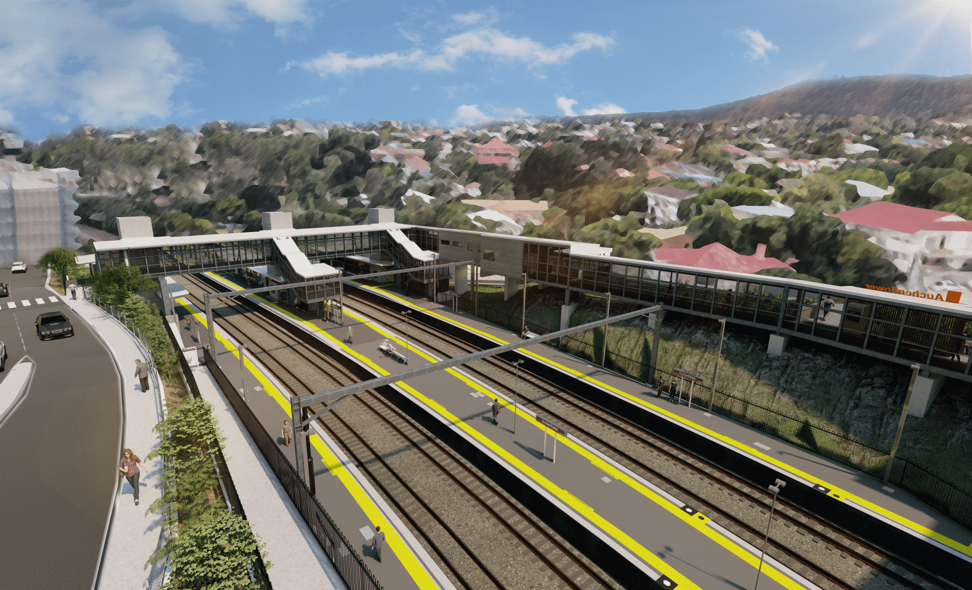
Auchenflower station accessibility upgrade

WORKS NOTICE

Wesley Hospital carpark access changes – Lang Parade closure
8pm Friday 23 to 5am Monday 26 July 2021

To support major construction activities for the Auchenflower station accessibility upgrade, Lang Parade will be closed (corner Chasely Street), from 8pm Friday 23 until 5am Monday 26 July. During this time all access to The Wesley Hospital public carpark will be via Patrick Lane (see map below). Auchenflower Terrace is also currently closed between Dixon Street and Ridley Street.
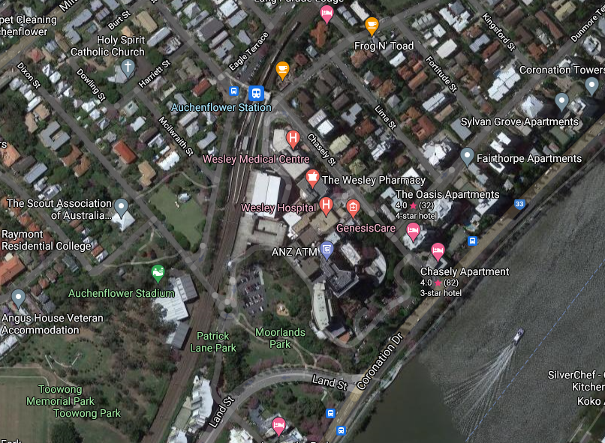
We apologise for any inconvenience as we undertake these important works.

Lang Pde

Auchenflower Tce

Queensland Rail Limited ABN 71 132 181 090
Patrick Ln

Wesley Hospital carpark entry

Map data © Google, 2021

Access to The Wesley Hospital carpark

Lang Parade and Auchenflower Terrace

ROAD CLOSED

For more information, please contact the project’s community team on free call 1800 722 203 or email stationsupgrade@qr.com.au

