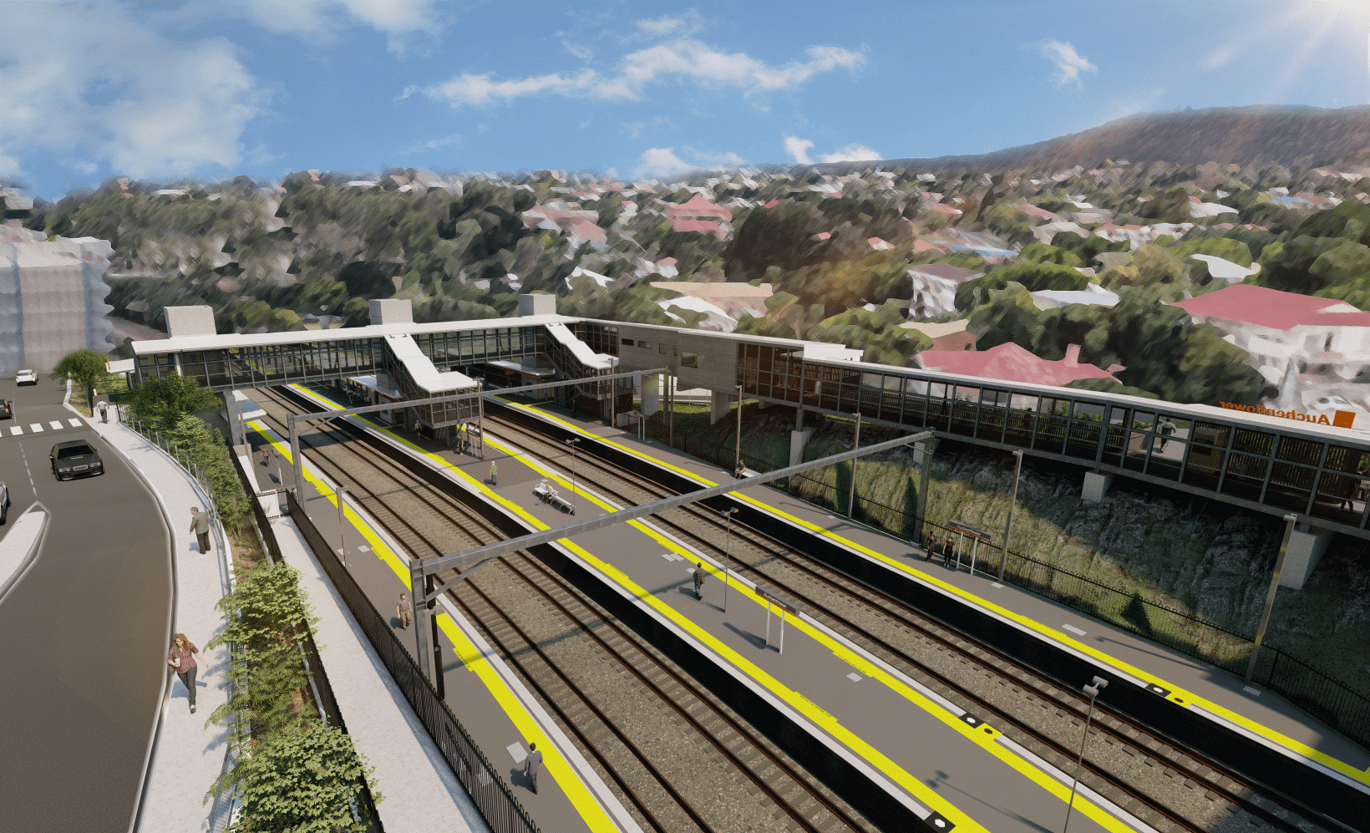
Auchenflower station accessibility upgrade

WORKS NOTICE

Wesley Hospital carpark access changes – Lang Parade closure
- 8pm Friday 20 to 5.30am Monday 23 May 2022
- Saturday 28 May 2022, 5am to 6pm
To construct the new pedestrian crossing as part of the Auchenflower station accessibility upgrade, Lang Parade will be closed (at the corner Chasely Street), from 8pm Friday 20 until 5.30am Monday 23 May and again on Saturday 28 May, 5am to 6pm.
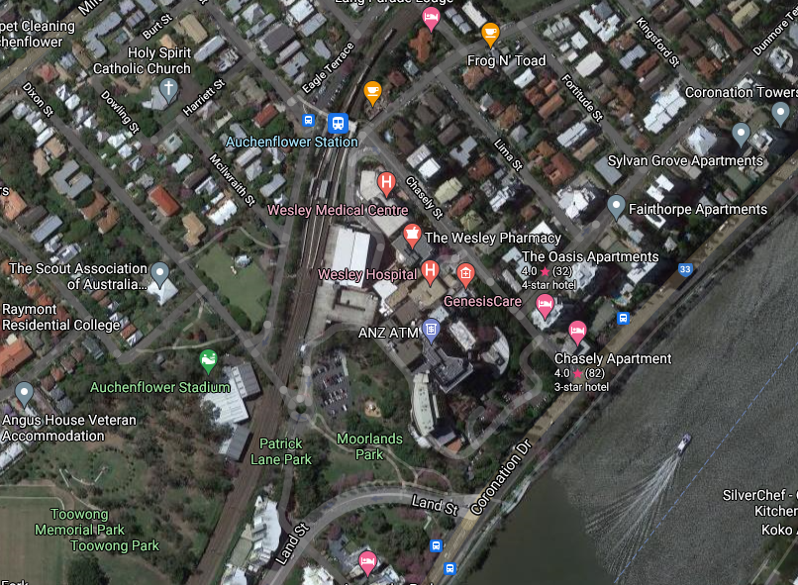
During these times all access to The Wesley Hospital public carpark will be via Patrick Lane (see map below). We apologise for any inconvenience as we undertake these important works.

Lang Parade closed

Access to The Wesley Hospital carpark
Auchenflower Tce
Lang Pde

Queensland Rail Limited ABN 71 132 181 090
Wesley Hospital carpark entry

Patrick Ln

Map data © Google, 2022
ROAD CLOSED

For more information, please contact the project’s community team on free call 1800 722 203 or email stationsupgrade@qr.com.au

