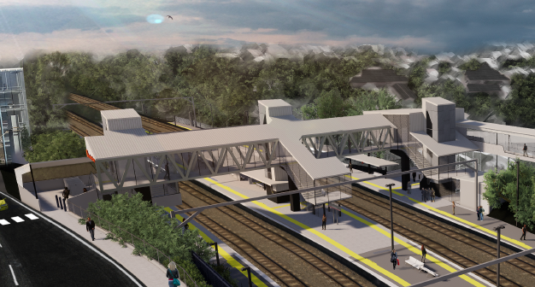
Auchenflower station accessibility upgrade

WORKS NOTICE

Night works and lane closure
December 2020

As part of the Auchenflower station accessibility upgrade, Queensland Rail will undertake night works between 10pm and 5am on selected nights in December 2020 (weather and construction conditions permitting).
For safety, these works can only be undertaken at night when there is reduced rail traffic.
Residents near the station may experience some noise associated with construction activity, the operation of machinery and the movement of vehicles and equipment around the work zone.
During works, the station concourse will be open to pedestrian traffic when safe for public access, but may be closed for up to two hours at a time during concrete pumping activities.
Every effort will be made to minimise disruption and we apologise for any inconvenience as we build you a better Auchenflower station.
A similar period of night works is planned for early-mid January 2021 – to be notified in more detail closer to the date.

Overview of weekend works
Queensland Rail Limited ABN 71 132 181 090
Location | Dates and hours of work | Type of work
Auchenflower station precinct including platforms, subway and carpark – closed  Station concourse – open when safe; closed for 2 hours at a time  Rail corridor access gates (near Dixon Street, Eagle Terrace/Cue Street and Lang Parade)  Auchenflower Terrace – lane closure | 10pm to 5am the next day on:  - Thursday 3 December  - Sunday 6 to Thursday 10 December  - Sunday 13 to Thursday 17 December.  (over 11 separate nights) | Station upgrade construction works involving:  - excavation and earthworks  - foundations and footings  - operation of excavators, trucks, on-track vehicles and machinery with flashing lights and reversing beepers  - use of saws, hand-held tools and powered equipment  - movement of personnel and vehicles around the station and in the rail corridor  - portable lighting towers in use at night  - Traffic management – Auchenflower Terrace (between Eagle Terrace and McIlwraith Street).
The Auchenflower station accessibility upgrade is part of the State Government’s investment to upgrade stations across the South East Queensland network, making them accessible for all customers. For more information, please contact the project’s community team on free call 1800 722 203 or email stationsupgrade@qr.com.au

