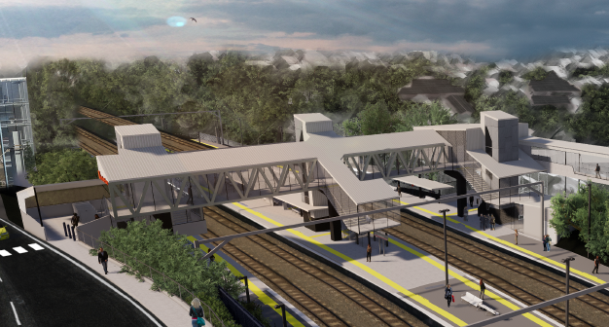
Auchenflower station accessibility upgrade

WORKS NOTICE

Night works
Sunday 1 and Monday 2 November 2020

As part of the Auchenflower station accessibility upgrade, Queensland Rail will undertake overhead line infrastructure works and associated station upgrade activities on Sunday 1 and Monday 2 November 2020, each night from 9pm to 4am the next day (weather and construction conditions permitting).
Works have been scheduled at night, when there is reduced rail traffic and the overhead power is switched off.
Residents near the station may experience some noise associated with construction activity, the operation of machinery and the movement of vehicles and equipment around the work zone.
Traffic management will be in operation on Lang Parade (near The Wesley Hospital public carpark entrance). Motorists are requested to follow the instruction of the traffic controllers. Access to private property will be maintained.
Every effort will be made to minimise disruption and we apologise for any inconvenience as we build you a better Auchenflower station.

Overview of night works
Queensland Rail Limited ABN 71 132 181 090
Location | Dates and hours of work | Type of work
Auchenflower station, carpark and rail corridor  Rail corridor access gates (near Dixon Street and Eagle Terrace/Cue Street)  Traffic management on Lang Parade | 9pm to 4am the next day on:  - Sunday 1 November  - Monday 2 November  (over 2 nights) | Station upgrade works involving:  - installation of steel masts and overhead line equipment and removal of old masts  - operation of cranes, excavators, trucks, on-track vehicles and machinery with flashing lights and reversing beepers  - removal of platform shelter structures – steel cutting and crane operation  - use of saws, hand-held tools and powered equipment  - movement of personnel and vehicles around the station and in the rail corridor  - portable lighting towers in use at night.
The Auchenflower station accessibility upgrade is part of Queensland Rail’s program to upgrade stations across the South East Queensland network, making them accessible for all customers.
For more information, please contact the project’s community team on free call 1800 722 203 or email stationsupgrade@qr.com.au

