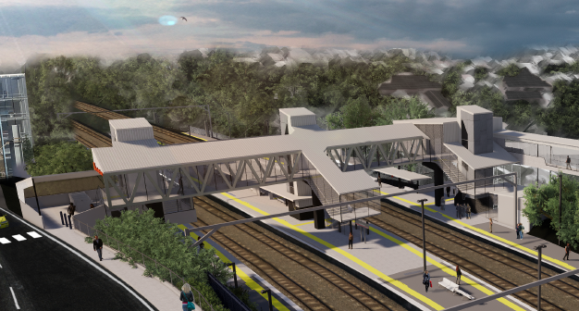
Auchenflower station accessibility upgrade

WORKS NOTICE

Night works – signalling activities

UPDATE October 2020

Due to program and resourcing changes, Queensland Rail has rescheduled the previously notified signalling infrastructure works to now be undertaken from 9pm to 5am the next day on Sunday 11, Saturday 17 and Sunday 18 October 2020 (weather and construction conditions permitting).
These works have been scheduled at night, when there is reduced rail traffic and the power to the overhead lines is switched off.
Residents near the station may experience some noise associated with construction activity, the operation of machinery and the movement of vehicles and equipment around the work zone.
Every effort will be made to minimise disruption and we apologise for any inconvenience as we build you a better Auchenflower station.

Overview of night works
Queensland Rail Limited ABN 71 132 181 090
Location | Dates and hours of work | Type of work
Auchenflower station, carpark and rail corridor  Eagle Terrace (near carpark)  Rail corridor access gates (near Dixon Street and Eagle Terrace/Cue Street) | 9pm to 5am the next day on:  - Sunday 11 October  - Saturday 17 October  - Sunday 18 October  (over 3 separate nights) | Signalling infrastructure works involving:  - installing cabling on platform  - excavation and drilling  - hand-held tools and powered equipment  - movement of personnel and vehicles around the station and in the rail corridor  - portable lighting towers in use at night.

The Auchenflower station accessibility upgrade is part of Queensland Rail’s program to upgrade stations across the South East Queensland network, making them accessible for all customers.
For more information, please contact the project’s community team on free call 1800 722 203 or email stationsupgrade@qr.com.au

