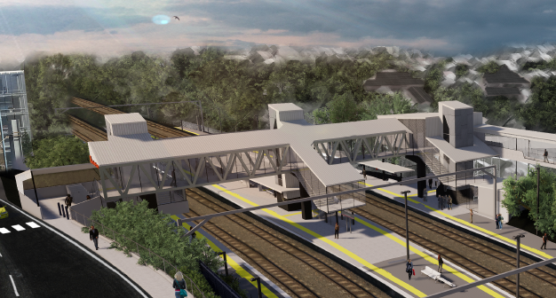
Auchenflower station accessibility upgrade

WORKS NOTICE

Night works – overhead activities
- Thursday 14 May 2020 (night works only)
- Monday 18 May 2020 (including road closure)
- Monday 25 to Thursday 28 May 2020 (night works only)

In preparation for the Auchenflower station accessibility upgrade, Queensland Rail will install overhead line infrastructure on selected nights in May, each night from 9pm to 4am the next day (weather and construction conditions permitting). These works have been scheduled at night, when there is reduced rail traffic and the power to the overhead lines can be switched off.
The intersection of Auchenflower Terrace and McIlwraith Street will be closed at night on Monday 18 May, for the safe operation of a large crane (see map over the page). Traffic management will be in operation and we ask motorists to drive to the changed road conditions. Local access will be maintained at all times at the instruction of the traffic controller.
Residents near the station may experience some noise associated with construction activity and the operation of vehicles and equipment around the work zone. Every effort will be made to minimise disruption and we apologise for any inconvenience as we undertake these important early works.

Overview of works
Queensland Rail Limited ABN 71 132 181 090
Location | Dates and hours of work | Type of work
Auchenflower station and rail corridor  Auchenflower Terrace/McIlwraith Street (road closure, Monday 18 May)  Rail corridor access gates (near Dixon Street and Eagle Terrace/Cue Street) | Night works:  9pm to 4am the next day on:  - Thursday 14 May  (overnight works)  Night works and road closure:  - Monday 18 May, 9pm to 4am the next day  (overnight works)  Night works:  9pm to 4am the next day on:  - Monday 25 to Thursday 28 May  (over 4 nights) | Overhead infrastructure works involving:  - installation of steel masts and overhead line equipment  - operation of a large crane, trucks, on-track vehicles and machinery with flashing lights and reversing beepers  - hand-held tools and powered equipment  - movement of personnel and vehicles around the station and in the rail corridor  - road closure with traffic management and relocation of bus stop (Monday 18 May)  - portable lighting towers in use at night.
Novel Coronavirus (COVID-19) – Queensland Rail is committed to keeping essential rail services operating for Queenslanders during this challenging time and to do this, network maintenance and critical capital works must continue. To support workforce safety, Queensland Rail has implemented a number of additional control measures related to COVID-19 management. We will continue to take the necessary precautions to ensure the ongoing health and wellbeing of our team and the communities in which we operate.
The Auchenflower station accessibility upgrade is part of the State Government’s $357 million investment to upgrade stations across the South East Queensland network, making them accessible for all customers. For more information, please contact the project’s community team on free call 1800 722 203 or email stationsupgrade@qr.com.au

Sign up at queenslandrail.com.au/EmailNotification or contact us if you prefer to receive paper copies.

Page 2

Road closure and traffic management
Auchenflower Terrace/McIlwraith Street, Auchenflower
Monday 18 May 2020, 9pm to 4am the next day

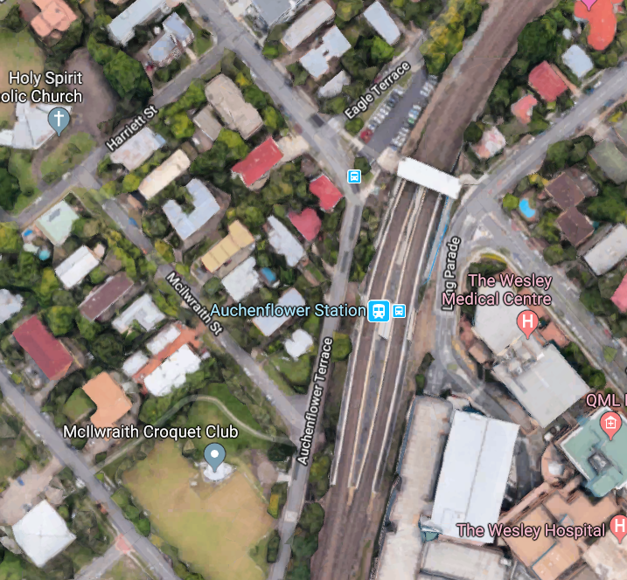

Ridley Street

Lang Parade

Road closure with traffic control – Auchenflower Terrace & McIlwraith Street

Crane location

Map data © Google, 2020

For more information, please contact the project’s community team on free call 1800 722 203 or email stationsupgrade@qr.com.au

We are moving towards paperless notifications about noise and works. You will still see paper notices as we transition to the new system. Sign up at queenslandrail.com.au/EmailNotification or contact us if you prefer to receive paper copies.

