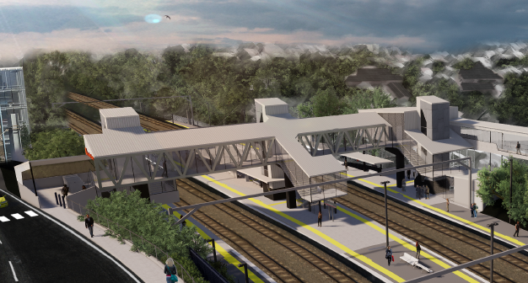
Auchenflower station accessibility upgrade

WORKS NOTICE

Night works and road closure – overhead line infrastructure
Sunday 22 March 2020

As part of ongoing early works for the Auchenflower station accessibility upgrade, Queensland Rail will install overhead line infrastructure overnight on Sunday 22 March, from 9pm to 4am the next day (weather and construction conditions permitting). For the safety of workers and the public, these works have been scheduled after hours, when there is reduced rail traffic.
During these works, the intersection of Auchenflower Terrace and McIlwraith Street will be closed for the safe operation of a large crane (see map over the page). Traffic management will be in operation and we ask motorists to drive to the changed road conditions. Local access will be maintained at all times at the instruction of the traffic controller.
Residents near the station may experience some noise associated with construction activity and the operation of trucks, on-track vehicles and equipment around the work zone.
Every effort will be made to minimise disruption and we apologise for any inconvenience as we undertake these important early works.

Overview of works
Queensland Rail Limited ABN 71 132 181 090
Location | Dates and hours of work | Type of work
Auchenflower station and rail corridor  Auchenflower Terrace/McIlwraith Street (road closure)  Rail corridor access gates (near Dixon Street and Eagle Terrace/Cue Street) | Sunday 22 March, 9pm to 4am the next day  (overnight works) | Overhead infrastructure works involving:  - installation of steel masts and equipment  - operation of a large crane, trucks, on-track vehicles and machinery with flashing lights and reversing beepers  - hand-held tools and powered equipment  - movement of personnel and vehicles around the station and in the rail corridor  - road closure with traffic management  - portable lighting towers in use at night.
The Auchenflower station accessibility upgrade is part of the State Government’s $357 million investment to upgrade stations across the South East Queensland network, making them accessible for all customers.
For more information, please contact the project’s community team on free call 1800 722 203 or email stationsupgrade@qr.com.au

We are moving towards paperless notifications about noise and works. You will still see paper notices as we transition to the new system. Sign up at queenslandrail.com.au/EmailNotification or contact us if you prefer to receive paper copies.

Page 2

Road closure and traffic management
Auchenflower Terrace/McIlwraith Street, Auchenflower
Sunday 22 March 2020, 9pm to 4am the next day

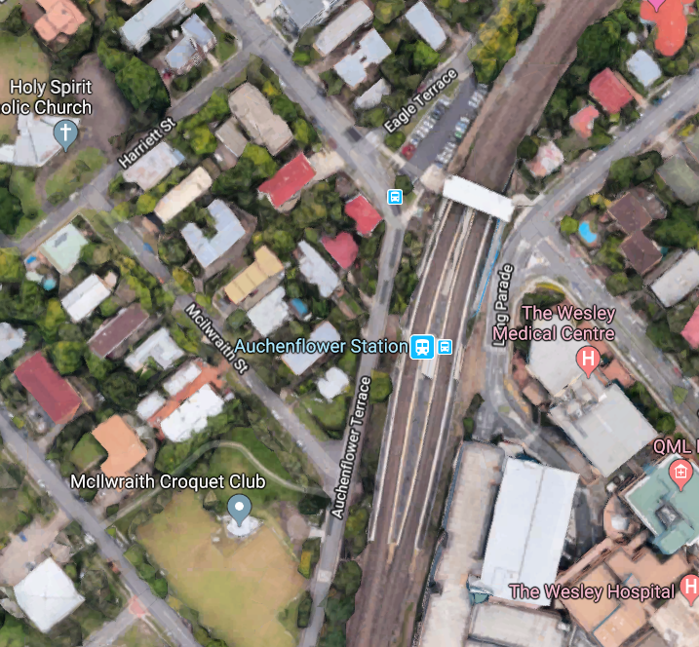

Ridley Street

Lang Parade

Road closure with traffic control – Auchenflower Terrace & McIlwraith Street

Crane location

Map data © Google, 2020

For more information, please contact the project’s community team on free call 1800 722 203 or email stationsupgrade@qr.com.au

We are moving towards paperless notifications about noise and works. You will still see paper notices as we transition to the new system. Sign up at queenslandrail.com.au/EmailNotification or contact us if you prefer to receive paper copies.

