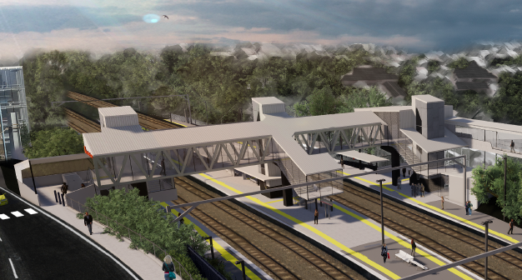
Auchenflower station accessibility upgrade

WORKS NOTICE

Night works – overhead line infrastructure activities

September 2020

As part of the Auchenflower station accessibility upgrade, Queensland Rail will undertake overhead line infrastructure works and associated activities on selected nights in September 2020, each night from 9pm to 4am the next day (weather and construction conditions permitting).
These works have been scheduled at night, when there is reduced rail traffic and the power to the overhead lines is switched off.
Residents near the station may experience some noise associated with construction activity, the operation of machinery and the movement of vehicles and equipment around the work zone.
Every effort will be made to minimise disruption and we apologise for any inconvenience as we build you a better Auchenflower station.

Overview of night works
Location | Dates and hours of work | Type of work  Queensland Rail Limited ABN 71 132 181 090
Auchenflower station, carpark and rail corridor  Eagle Terrace (near carpark)  Rail corridor access gates (near Dixon Street and Eagle Terrace/Cue Street) | 9pm to 4am the next day on:  - Monday 7 September  - Sunday 13 September  - Thursday 17 September  - Sunday 20 September  (over 4 separate nights) | Overhead infrastructure works involving:  - installation of steel masts and overhead line equipment and removal of old masts  - operation of a large crane, trucks, on-track vehicles and machinery with flashing lights and reversing beepers  - hand-held tools and powered equipment  - movement of personnel and vehicles around the station and in the rail corridor  - portable lighting towers in use at night.
Novel Coronavirus (COVID-19) – Queensland Rail is committed to keeping essential rail services operating for Queenslanders during this challenging time and to do this, network maintenance and critical capital works must continue. To support workforce safety, Queensland Rail has implemented a number of additional control measures related to COVID-19 management. We will continue to take the necessary precautions to ensure the ongoing health and wellbeing of our team and the communities in which we operate.

The Auchenflower station accessibility upgrade is part of the State Government’s $357 million investment to upgrade stations across the South East Queensland network, making them accessible for all customers.
For more information, please contact the project’s community team on free call 1800 722 203 or email stationsupgrade@qr.com.au

Sign up at queenslandrail.com.au/EmailNotification or contact us if you prefer to receive paper copies.

