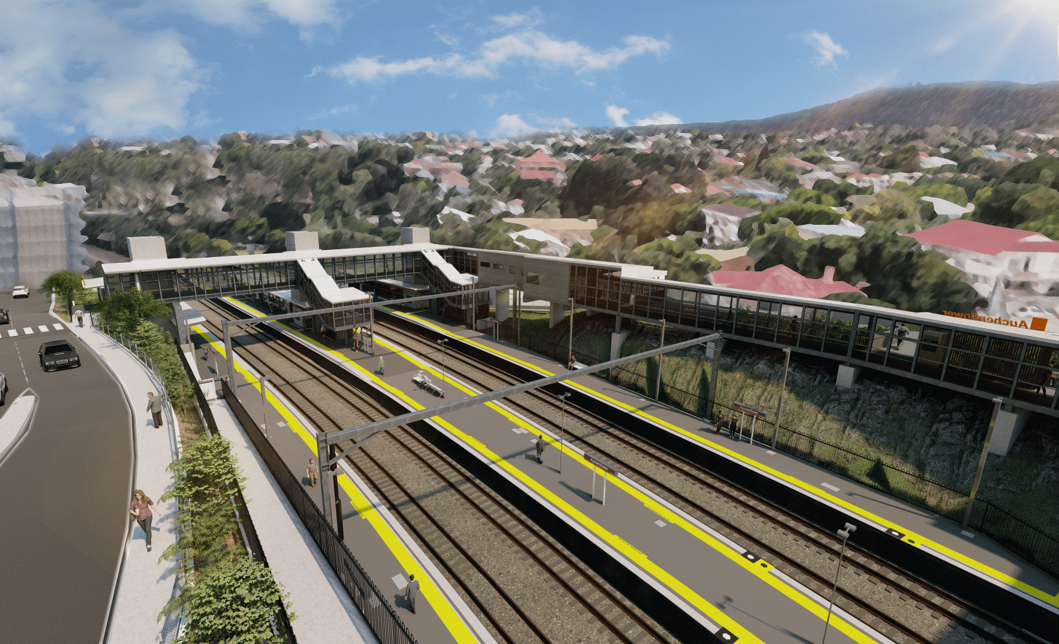
Auchenflower station accessibility upgrade

WORKS NOTICE

Night works
January/February 2022

As part of the Auchenflower station accessibility upgrade, Queensland Rail will undertake night works (6pm to 6am the next day) on selected nights in late January and early February 2022 (public holidays excluded).
These works can only be undertaken after hours when rail traffic is reduced and there are fewer people around the station precinct or to minimise impact to the road network surrounding The Wesley Hospital.
Lane closures with traffic management may be required at times on Lang Parade to support site access, concrete pours and other construction activities. Motorists are advised to follow the instructions of the traffic controllers and drive to the changed conditions.
Residents near the station may experience noise associated with concrete pours, construction activity and the operation of cranes, heavy vehicles and trucks around the work zone. Every effort will be made to minimise disruption and we thank you for your patience during these important works.

Overview of works (weather and construction conditions permitting)
Queensland Rail Limited ABN 71 132 181 090
Location | Dates and hours of work | Type of work
Auchenflower station and rail corridor  Auchenflower station carpark (closed until September)  Lang Parade, near hospital carpark (traffic management) | 6pm to 6am the next day on:  - Monday 24 January (if required)  - Tuesday 25 January (if required)  - Thursday 27 January  - Monday 31 January  - Tuesday 1 February  - Wednesday 2 February  - Thursday 3 February  (up to seven separate nights) | Station upgrade activities involving:  - operation of concrete pumping trucks  - operation of cranes and heavy equipment  - installation of an electrical switchboard  - demolition of old station building and preparation activities prior to removal  - the movement of vehicles and machinery with flashing lights and reversing beepers  - use of hand-held tools and powered equipment  - portable lighting towers in use at night  - lane closures and traffic management (Lang Parade).
The Auchenflower station accessibility upgrade is part of the State Government’s ongoing investment of more than $500 million to upgrade stations across the South East Queensland network, making them accessible for all customers.
For more information, please contact the project’s community team on free call 1800 722 203 or email stationsupgrade@qr.com.au
Sign up for electronic notifications at queenslandrail.com.au/EmailNotification

