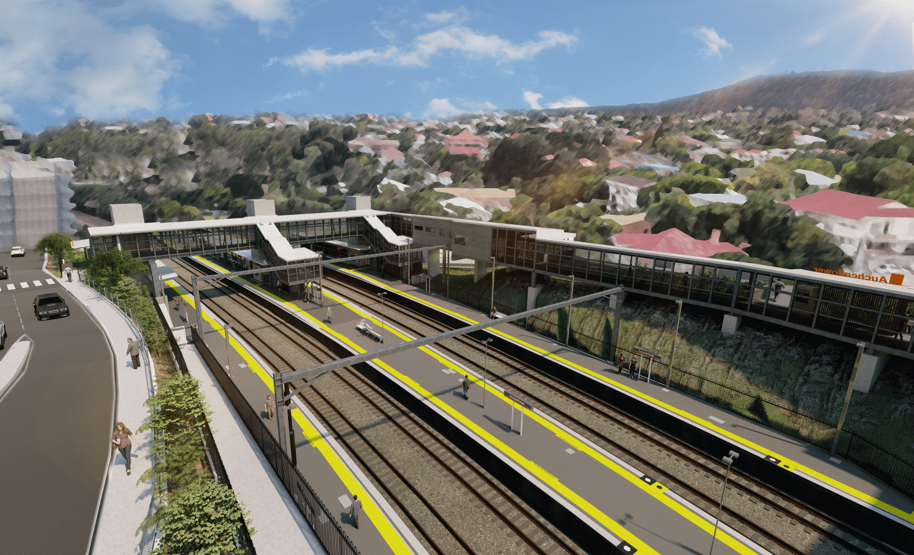
Auchenflower station accessibility upgrade

WORKS NOTICE

Night and weekend works UPDATED
September 2021

As part of the Auchenflower station accessibility upgrade, Queensland Rail will undertake night works (8pm to 5am the next day) on Thursday 16 and Tuesday 21 September (weather and construction conditions permitting).
These works are scheduled either side of the previously notified around-the-clock weekend activities, from 8pm Friday 17 to 5am Monday 20 September. These works involve the weekend closure of platform 4 (nearest to Auchenflower Terrace). The station will remain open over the weekend.
The current full road closure on Auchenflower Terrace, between Dixon Street and Ridley Street, will be in place until Friday 29 October 2021.
Residents near the station may experience some noise associated with construction activity and the operation of trucks and heavy equipment around the work zone. Every effort will be made to minimise disruption and we thank you for your understanding during these important works.

Overview of works
Location | Dates and hours of work | Type of work
Auchenflower station, carpark and rail corridor  Platform 4 – closed Saturday 18 and Sunday 19 September  Auchenflower Terrace (full road closure) | Night works – September:  8pm to 5am the next day on:  - Thursday 16 September  - Tuesday 21 September  Weekend works:  8pm Friday 17 to 5am Monday 20 September  (around-the-clock works, previously notified) | Station upgrade activities involving:  - screw piling (footbridge foundations)  - excavation and removal of spoil  - platform works  Queensland Rail Limited ABN 71 132 181 090  - platform 4 – closed 18 and 19 September  - operation of concrete trucks and heavy equipment  - movement of vehicles and machinery with flashing lights and reversing beepers  - use of hand-held tools and powered equipment  - portable lighting towers in use at night  - road closure and traffic management (Auchenflower Terrace).
The Auchenflower station accessibility upgrade is part of the State Government’s ongoing investment of more than $500 million to upgrade stations across the South East Queensland network, making them accessible for all customers.
For more information, please contact the project’s community team on free call 1800 722 203 or email stationsupgrade@qr.com.au

Sign up for electronic notifications at queenslandrail.com.au/EmailNotification

