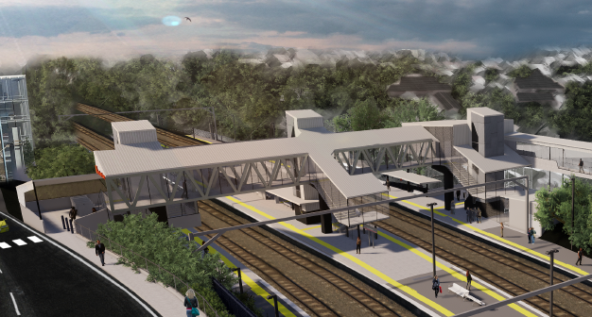
Auchenflower station accessibility upgrade

WORKS NOTICE

Night works – overhead line infrastructure
Monday 27 January 2020

In preparation for the Auchenflower station accessibility upgrade, Queensland Rail will install overhead line infrastructure on Monday 27 January, between 7.30pm and 6am the next day (weather and construction conditions permitting). For the safety of workers and the public, these works have been scheduled after hours, when there is no rail traffic. This is a continuation of works previously notified.
The station carpark will be closed enable the overnight operation of a large crane. Customers are requested to assist us by removing vehicles from the carpark by 7pm on Monday 27 January.
For safety, pedestrian access through the station carpark will be unavailable during the operation of the crane. Traffic control personnel will direct pedestrians around the work zone.
Residents near the station may experience some noise associated with the crane activity and the operation of trucks, on-track vehicles and equipment around the work zone. Every effort will be made to minimise disruption and we apologise for any inconvenience as we undertake these important early works.

Overview of night works
Queensland Rail Limited ABN 71 132 181 090
Location | Dates and hours of work | Type of work
Auchenflower station  Station carpark – closed  Eagle Terrace (near carpark entry)  Rail corridor access gates (near Dixon Street and Eagle Terrace/Cue Street) | Monday 27 January, 7.30pm to 6am the next day  (overnight works) | Overhead infrastructure works involving:  - operation of a large crane  - installation of steel masts and equipment  - movement of trucks, on-track vehicles and machinery with flashing lights and reversing beepers  - hand-held tools and powered equipment  - movement of personnel and vehicles around the station and in the rail corridor  - lane closures with traffic management  - portable lighting towers in use at night  - traffic management, Eagle Terrace entry.
The Auchenflower station accessibility upgrade is part of the State Government’s $357 million investment to upgrade stations across the South East Queensland network, making them accessible for all customers. For more information, please contact the project’s community team on free call 1800 722 203 or email stationsupgrade@qr.com.au

We are moving towards paperless notifications about noise and works. You will still see paper notices as we transition to the new system. Sign up at queenslandrail.com.au/EmailNotification or contact us if you prefer to receive paper copies.

