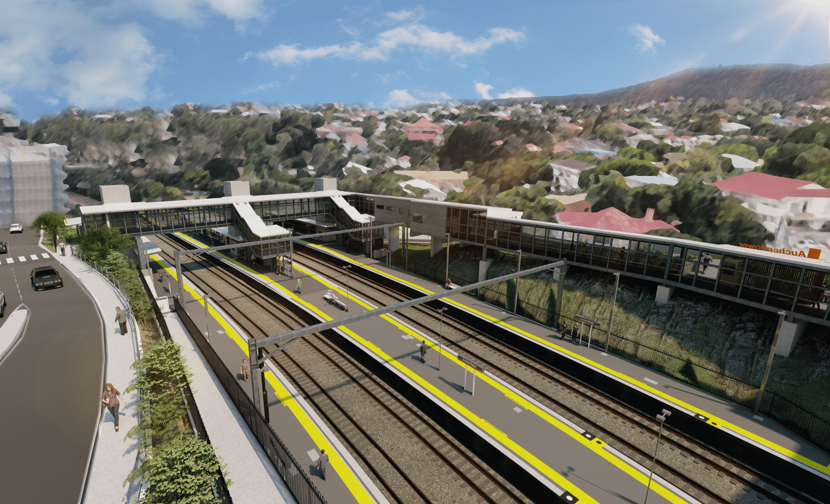
Auchenflower station accessibility upgrade

WORKS NOTICE

Night works
Monday 25 to Friday 29 April 2022

As part of the Auchenflower station accessibility upgrade, Queensland Rail will undertake night works from Monday 25 to Wednesday 27 April (9.30pm to 6am the next day) with an early morning concrete pour scheduled from 3.30am on Friday 29 April.
For safety, these works can only be undertaken after hours when rail traffic is reduced and there are fewer people around the station and hospital precincts.
Traffic management may be required to support site access, concrete pumping and other construction activities. Motorists are advised to follow the instructions of the traffic controllers and drive to the changed conditions.
Residents near the station may experience noise associated with concrete pumping, truck movements and construction activity around the work zone.
Every effort will be made to minimise disruption and we thank you for your patience during these important works.

Overview of works (weather and construction conditions permitting)
Queensland Rail Limited ABN 71 132 181 090
Location | Dates and hours of work | Type of work
Auchenflower station, carpark and rail corridor  Surrounding local streets (including Lang Parade) | Night works, 9.30pm to 6am the next day on:  - Monday 25 April  - Tuesday 26 April  - Wednesday 27 April  - Thursday 28 April (concrete pour at 3.30am Friday 29 April).  (over four nights) | Station upgrade activities involving:  - loading materials and equipment onto the platform for future works  - concrete pumping and concrete works  - operation of machinery and heavy equipment  - the movement of loaders, vehicles and machinery with flashing lights and reversing beepers  - use of hand-held tools and powered equipment  - portable lighting towers in use at night  - lane closure (Lang Parade) with traffic management (as required).

The Auchenflower station accessibility upgrade is part of the State Government’s ongoing investment of more than $500 million to upgrade stations across the South East Queensland network, making them accessible for all customers.
For more information, please contact the project’s community team on free call 1800 722 203 or email stationsupgrade@qr.com.au

Sign up for electronic notifications at queenslandrail.com.au/EmailNotification

