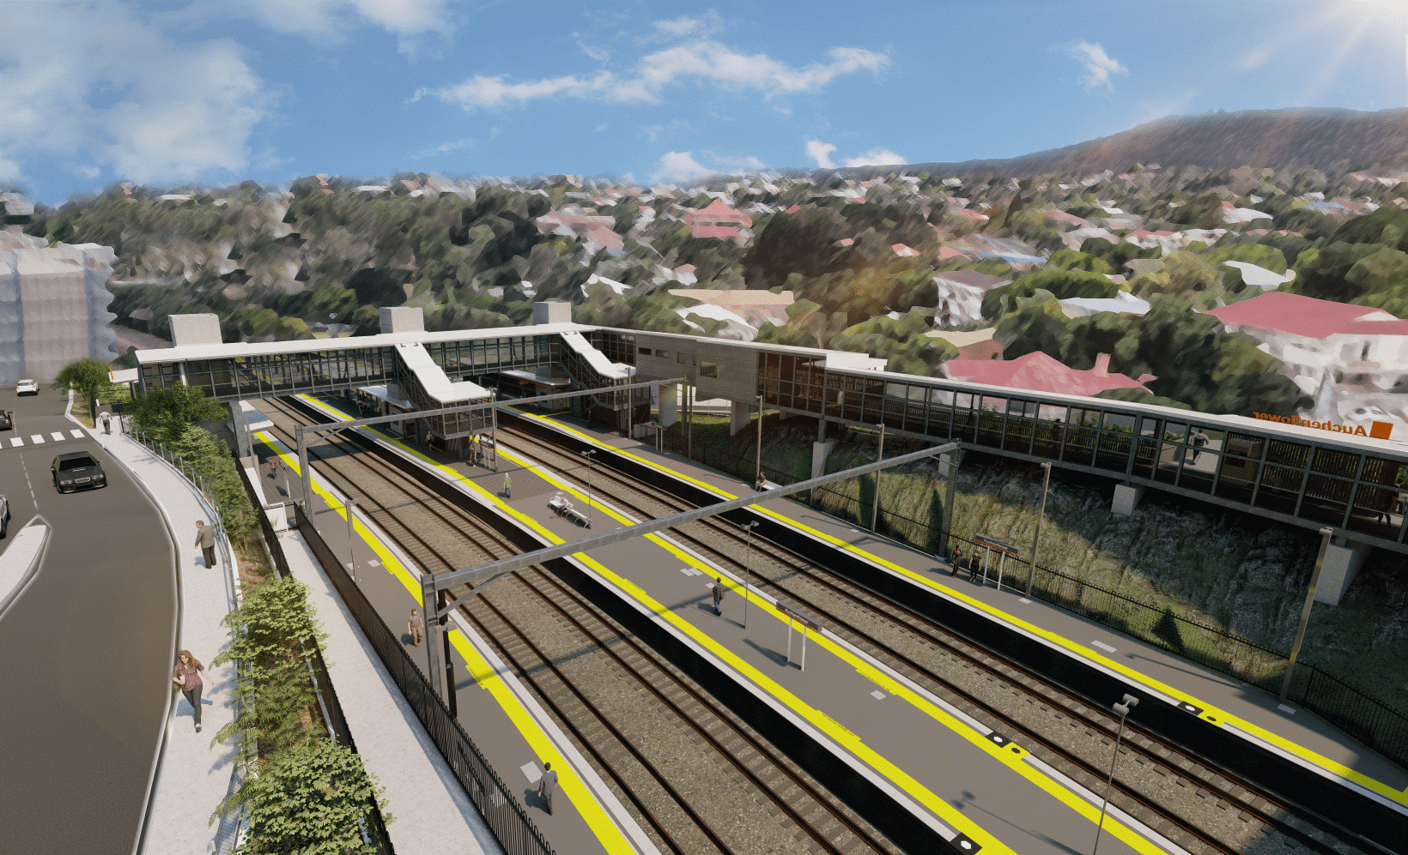
Auchenflower station accessibility upgrade

WORKS NOTICE

Night works
Late June 2022

As part of the Auchenflower station accessibility upgrade, Queensland Rail will undertake after hours works on selected nights in the second half of June (6pm to 6am the next day).
For safety, these works can only be undertaken after hours when rail traffic is reduced and there are fewer people around the station and hospital precincts.
Traffic management will be in operation to support site access, concrete pumping and other construction activities. Motorists are advised to follow the instructions of the traffic controllers and drive to the changed conditions.
Residents near the station may experience noise associated with excavation, concrete pumping, truck movements and construction activity around the work zones.
Every effort will be made to minimise disruption and we thank you for your patience during these important works.

Overview of works (weather and construction conditions permitting)
Queensland Rail Limited ABN 71 132 181 090
Location | Dates and hours of work | Type of work
Auchenflower station, carpark and rail corridor  Surrounding local streets (including Lang Parade) | Night works, 6pm to 6am the next day on:  - Monday 20 June  - Wednesday 22 June  - Monday 27 June  - Wednesday 29 June.  (four separate nights over two weeks) | Station upgrade activities involving:  - abutment works (new pedestrian footbridge)  - property pole installation (Lang Parade)  - excavation  - installation of in-ground services  - concrete pumping and concrete works  - footpath sub-grade works  - operation of machinery and heavy equipment  - use of hand-held tools and powered equipment  - delivery and unloading of materials by truck  - the movement of vehicles and machinery with flashing lights and reversing beepers  - portable lighting towers in use at night  - lane/road closures (Lang Parade) with traffic management (as required).
The Auchenflower station accessibility upgrade is part of the State Government’s ongoing investment of more than $500 million to upgrade stations across the South East Queensland network, making them accessible for all customers.
For more information, please contact the project’s community team on free call 1800 722 203 or email stationsupgrade@qr.com.au

Sign up for electronic notifications at queenslandrail.com.au/EmailNotification

