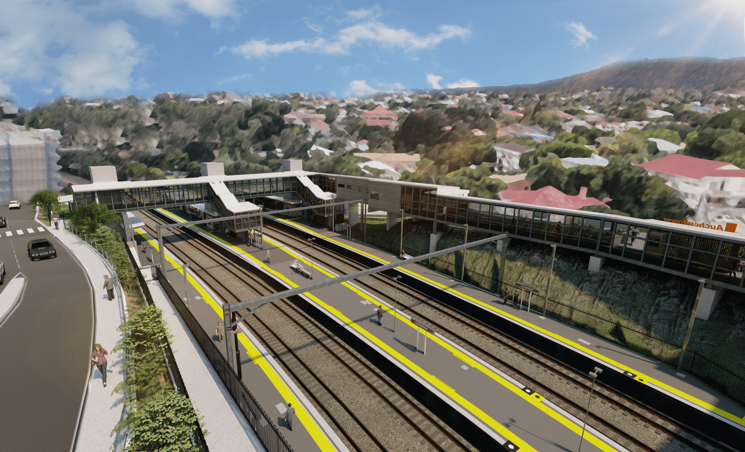
Auchenflower station accessibility upgrade

WORKS NOTICE

Night and after hours works
February and March 2022

As part of the Auchenflower station accessibility upgrade, Queensland Rail will undertake night works (6pm to 6am the next day) over five weeks in February and March to facilitate the demolition of old station infrastructure.
On either side of this extended period of night works will be around-the-clock weekend works during scheduled track closures, on the weekend 12 and 13 February and again on 19 and 20 March.
For safety, these works can only be undertaken when the track is closed or after hours when rail traffic is reduced and there are fewer people around the station precinct.
Lane closures with traffic management may be required at times to support site access, concrete pours and other construction activities. Motorists are advised to follow the instructions of the traffic controllers and drive to the changed conditions.
Residents near the station may experience noise associated with demolition works, concrete pours, construction activity and the operation of cranes, heavy vehicles and trucks around the work zone. Every effort will be made to minimise disruption and we thank you for your patience during these important works.

Overview of works (weather and construction conditions permitting)
Queensland Rail Limited ABN 71 132 181 090
Location | Dates and hours of work | Type of work
Auchenflower station and rail corridor  Auchenflower station carpark (closed until September)  Lang Parade, near hospital carpark (traffic management) | During weekend track closure:  - 6pm Friday 11 to 6am Monday 14 February  (around-the-clock works)  Night works:  6pm until 6am the next day on:  - Monday 14 to Friday 18 February  - Monday 21 to Friday 25 February  - Monday 28 February to Friday 4 March  - Monday 7 to Friday 11 March  - Monday 14 to Thursday 17 March  (weeknights M-F over five weeks)  During weekend track closure:  - 6pm Friday 18 to 6am Monday 21 March  (around-the-clock works) | Station upgrade activities involving:  - demolition of old station building in preparation for its removal (nights)  - operation of a large crane (March)  - operation of powered saws, machinery and heavy equipment  - operation of concrete pumping trucks  - paving and roofing works  - the movement of vehicles and machinery with flashing lights and reversing beepers  - use of hand-held tools and powered equipment  - portable lighting towers in use at night  - lane closures and traffic management (Lang Parade).
The Auchenflower station accessibility upgrade is part of the State Government’s ongoing investment of more than $500 million to upgrade stations across the South East Queensland network, making them accessible for all customers. For more information, please contact the project’s community team on free call 1800 722 203 or email stationsupgrade@qr.com.au
Sign up for electronic notifications at queenslandrail.com.au/EmailNotification

