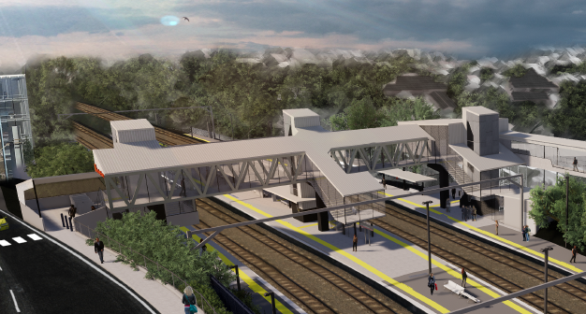
Auchenflower station accessibility upgrade

WORKS NOTICE

Night works and road closures
April 2021
As part of the Auchenflower station accessibility upgrade, Queensland Rail will undertake excavation and concreting works for the new footbridge footings (foundations) on selected nights in April 2021 (weather and construction conditions permitting). These works have been scheduled after hours when rail traffic is reduced and there are fewer people around the station precinct.
The station subway will be closed to the public during the concrete pours. The station building concourse will remain open for cross-corridor pedestrian access.
On selected date, localised road closures with traffic diversions will be in operation (see table, below).
Residents near the station may experience some noise associated with construction activity and the operation of excavators, concrete pumping trucks and equipment around the work zone.
Every effort will be made to minimise disruption and we thank you for your patience while we build you a better Auchenflower station.

Overview of works
Queensland Rail Limited ABN 71 132 181 090
Location | Dates and hours of work | Type of work
Auchenflower station, carpark and rail corridor  Station subway (closed during concrete pours) | 7pm to 5am the next day on:  - Monday 12 April  - Thursday 15 April  - Friday 16 April  - Monday 19 to Friday 23 April  - Tuesday 27 April to Saturday 1 May  (over 13 separate nights) | Station upgrade activities involving:  - excavation  - concrete pours  - operation of concrete trucks and movement of vehicles and machinery with flashing lights and reversing beepers  - use of hand-held tools and powered equipment  - portable lighting towers in use at night.
Lang Parade (near hospital carpark)  Auchenflower Terrace (between McIlwraith Street and Ridley Street) | Lang Parade closed 6am to 3pm on:  - Saturday 10 April  Auchenflower Terrace closed 6am to 5pm on:  - Saturday 17 April  - Thursday 22 to Saturday 24 April | Traffic management:  - Lang Parade – full road closure with traffic control near entrance to The Wesley Hospital carpark  - Auchenflower terrace – full road closure with traffic diversion via McIlwraith Street, Harriett Street and Ridley Street  - single-lane closures under traffic control at other times, as required.
The Auchenflower station accessibility upgrade is part of the State Government’s ongoing investment of more than $500 million to upgrade stations across the South East Queensland network, making them accessible for all customers.
For more information, please contact the project’s community team on free call 1800 722 203 or email stationsupgrade@qr.com.au

