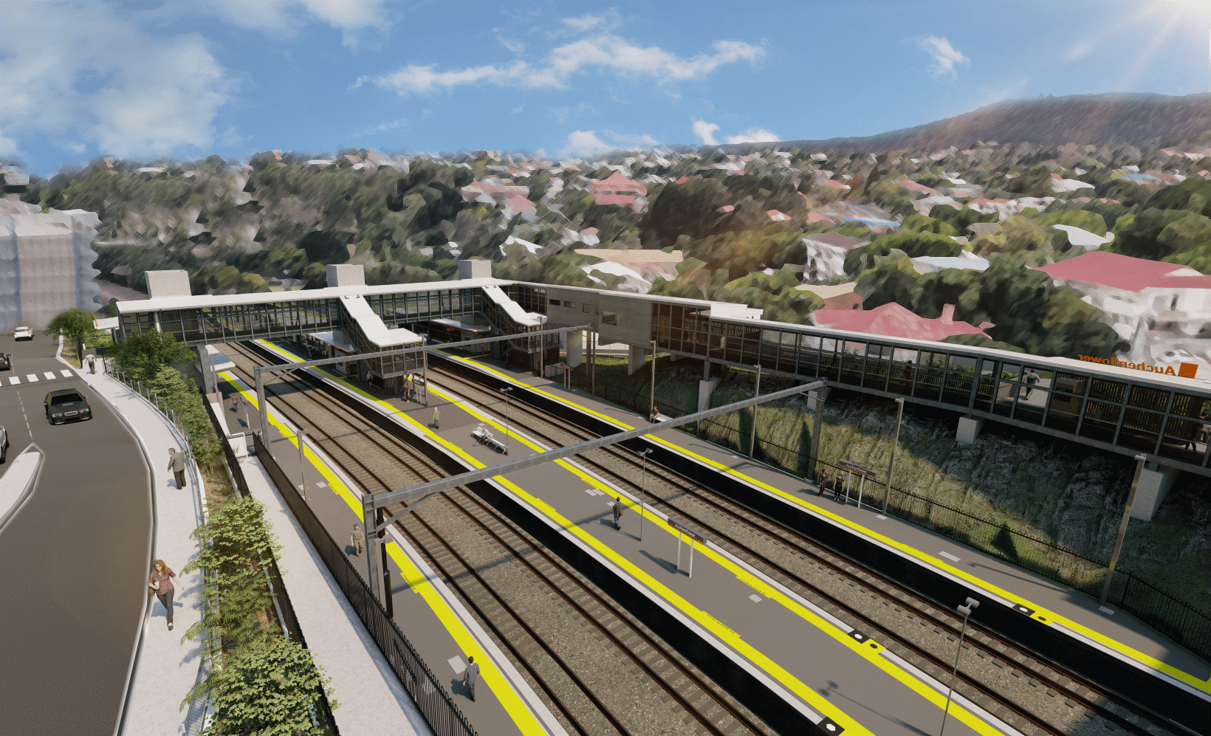
Auchenflower station accessibility upgrade

WORKS NOTICE

Night works
April 2022

As part of the Auchenflower station accessibility upgrade, Queensland Rail will undertake after hours works on selected nights in April.
For safety, these works can only be undertaken after hours when rail traffic is reduced and there are fewer people around the station precinct.
These works are a continuation of activities previously notified. Activities include concrete pumping related to the Lang Parade abutment for the new pedestrian footbridge, due to be installed in May.
Traffic management in Lang Parade, near the work zone, may be required to support concrete trucks and construction activities.
Residents near the station may experience noise associated with trucks movements and construction activity. Every effort will be made to minimise disruption and we thank you for your patience during these important works.

Overview of works (weather and construction conditions permitting)
Queensland Rail Limited ABN 71 132 181 090
Location | Dates and hours of work | Type of work
Auchenflower station, carpark and rail corridor  Lang Parade (between Chasely Street and the hospital carpark) | Selected night works, 6pm to 6am the next day on:  - Monday 11 April  - Tuesday 12 April  - Wednesday 20 April  - Thursday 21 April.  (four separate nights over two weeks)  Note: Works previously notified for March and April still apply. | Station upgrade activities involving:  - operation of concrete pumping trucks  - bridge abutment works  - roadworks and linemarking (pedestrian crossing, Lang Parade)  - operation of machinery and heavy equipment  - the movement of vehicles and machinery with flashing lights and reversing beepers  - use of hand-held tools and powered equipment  - portable lighting towers in use at night  - lane closures (Lang Parade) with traffic management (if/as required).

The Auchenflower station accessibility upgrade is part of the State Government’s ongoing investment of more than $500 million to upgrade stations across the South East Queensland network, making them accessible for all customers.
For more information, please contact the project’s community team on free call 1800 722 203 or email stationsupgrade@qr.com.au
Sign up for electronic notifications at queenslandrail.com.au/EmailNotification

