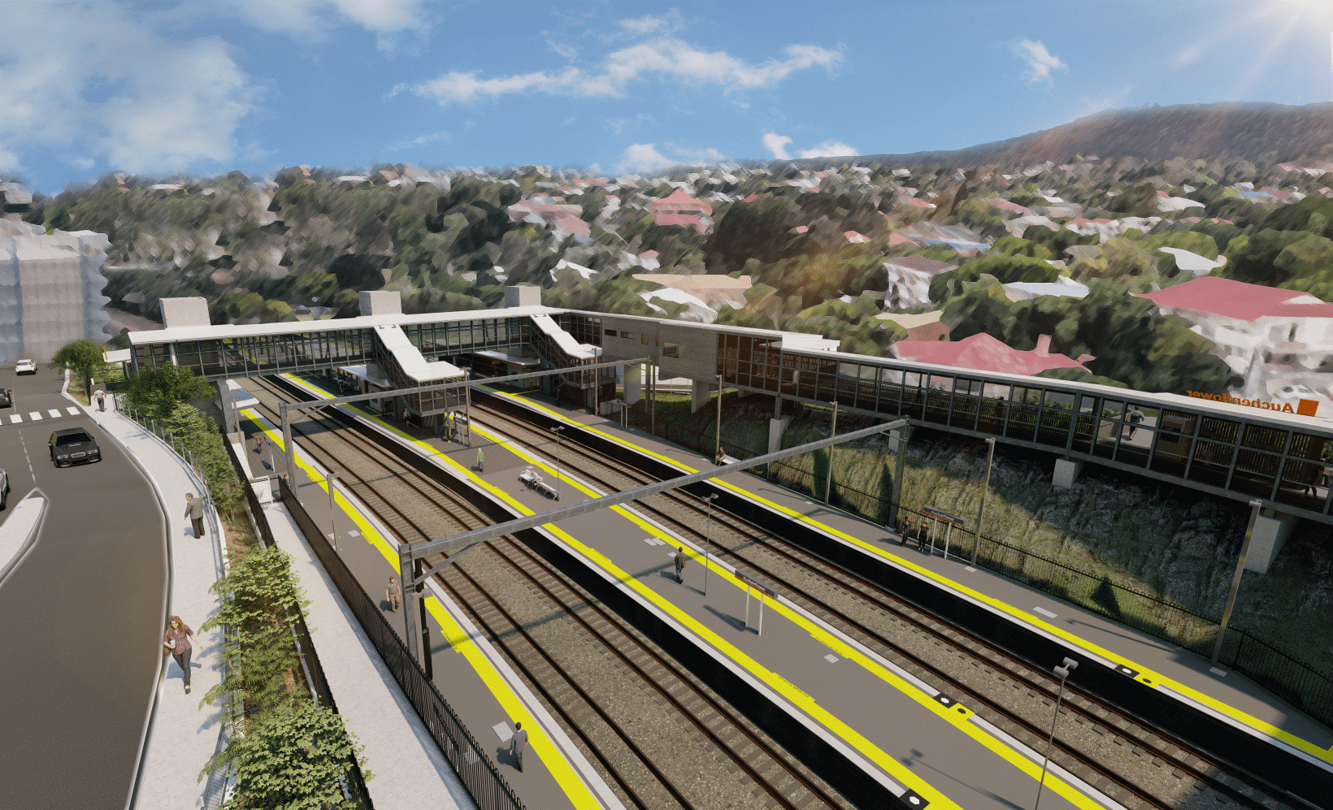
Auchenflower station accessibility upgrade

WORKS NOTICE

Night works
August/September 2021

As part of the Auchenflower station accessibility upgrade, Queensland Rail will undertake night works (8pm to 5am the next day) on selected nights in late August and early September 2021, weather and construction conditions permitting.
These works can only be undertaken after hours when rail traffic is reduced and there are fewer people around the station precinct.
To support these works on these nights, there may be single-lane closures (under traffic control) on Lang Parade, near the hospital precinct. The current closure on Auchenflower Terrace, between Dixon Street and Ridley Street, will be in place until Friday 29 October 2021.
Residents near the station may experience some noise associated with construction activity and the operation of excavators, loaders, concrete pumping trucks and equipment around the work zone.
Due to the availability of equipment and resources, some work dates may change without notice.
Every effort will be made to minimise disruption and we thank you for your understanding during these important works.

Overview of works
Location | Dates and hours of work | Type of work
Auchenflower station, carpark and rail corridor  Station subway (closed during concrete pours)  Auchenflower Terrace and Lang Parade (lane closures) | 8pm to 5am the next day on:  - Wednesday 25 August  - Thursday 26 August  - Friday 27 August  - Wednesday 1 September  (four nights over two weeks)  Note: Date of these works may change without further notice. | Station upgrade activities involving:  - excavation and removal of spoil  - concrete pours  Queensland Rail Limited ABN 71 132 181 090  - platform works  - operation of concrete trucks and loaders  - movement of vehicles and machinery with flashing lights and reversing beepers  - use of hand-held tools and powered equipment  - portable lighting towers in use at night  - single-lane closures under traffic control, as required (Lang Parade).
The Auchenflower station accessibility upgrade is part of the State Government’s ongoing investment of more than $500 million to upgrade stations across the South East Queensland network, making them accessible for all customers.
For more information, please contact the project’s community team on free call 1800 722 203 or email stationsupgrade@qr.com.au

Sign up for electronic notifications at queenslandrail.com.au/EmailNotification

