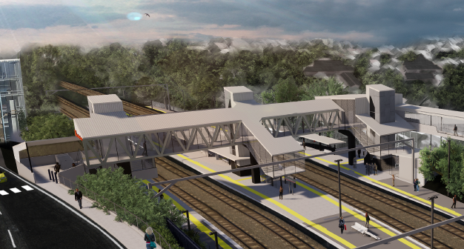
Auchenflower station accessibility upgrade

WORKS NOTICE

Night works – overhead line infrastructure
February 2020

The program of early works in preparation for the Auchenflower station accessibility upgrade continues with overhead line infrastructure installation on selected nights in February, between 9pm and 5am the next day (weather and construction conditions permitting). For the safety of workers and the public, these works have been scheduled after hours, when there is reduced rail traffic.
A lane closure with traffic management will be in operation as required – see below for locations and details. During lane closures, local and hospital access will be maintained at the instruction of the traffic controller.
Residents near the station may experience some noise associated with construction activity and the operation of cranes and truck movements around the work zone. Every effort will be made to minimise disruption and we apologise for any inconvenience as we undertake this concentrated period of early works.

Overview of night works
Queensland Rail Limited ABN 71 132 181 090
Location | Dates and hours of work | Type of work
Auchenflower station and rail corridor  Lane closures and traffic management:  - Lang Parade (Sunday 9 and Saturday 15 February)  - Eagle Terrace/Auchenflower Terrace (Monday 17 February)  Rail corridor access gates (near Dixon Street and Eagle Terrace/ Cue Street) | From 9pm to 5am the next day on:  - Sunday 9 and Monday 10 February  - Saturday 15 February  - Monday 17 to Thursday 20 February  - Wednesday 26 and Thursday 27 February | Overhead infrastructure works involving:  - crane operation  - electrical works  - operation of machinery and trucks with flashing lights and reversing beepers  - hand-held tools and powered equipment  - movement of personnel and vehicles around the station and in the rail corridor  - lane closures with traffic management  - portable lighting towers in use at night.
The Auchenflower station accessibility upgrade is part of the State Government’s $357 million investment to upgrade stations across the South East Queensland network, making them accessible for all customers.
For more information, please contact the project’s community team on free call 1800 722 203 or email stationsupgrade@qr.com.au

We are moving towards paperless notifications about noise and works. You will still see paper notices as we transition to the new system. Sign up at queenslandrail.com.au/EmailNotification or contact us if you prefer to receive paper copies.

