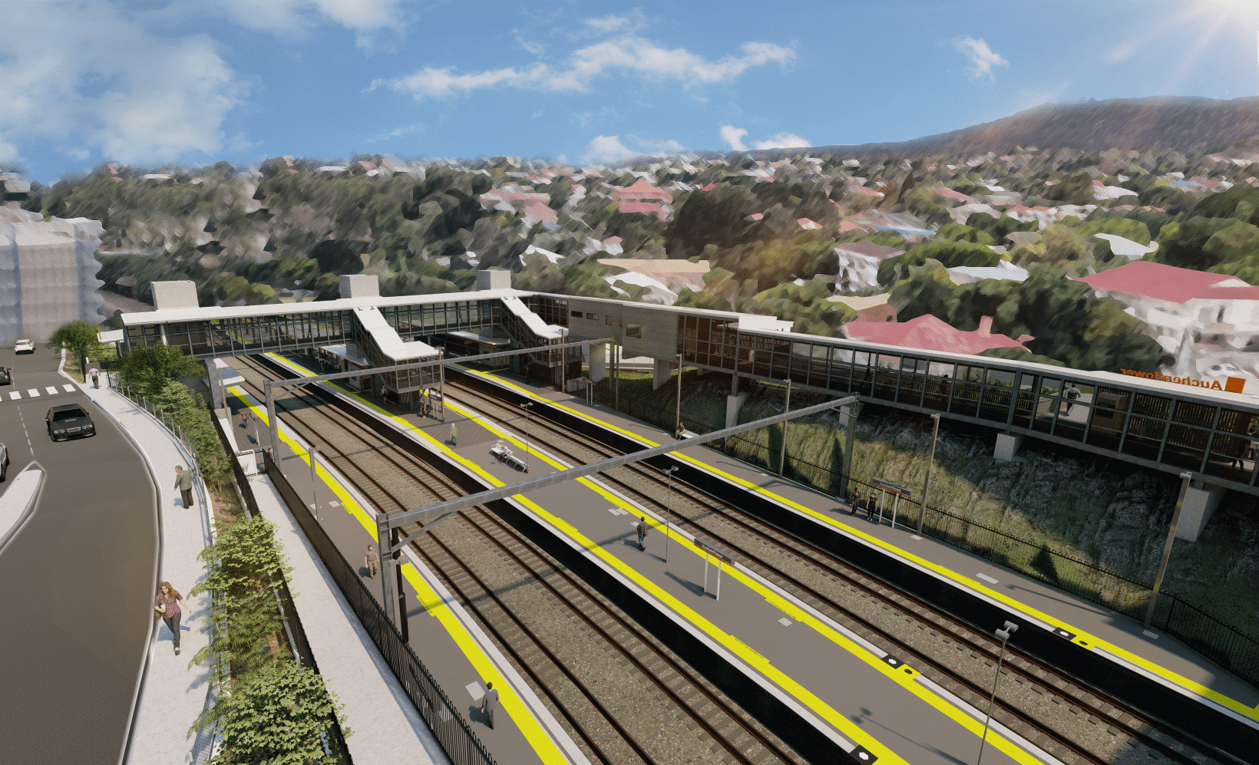
Auchenflower station accessibility upgrade

WORKS NOTICE

After hour works and road closures
July 2021

As part of the Auchenflower station accessibility upgrade, Queensland Rail will undertake night works (8pm to 5am the next day) from Sunday 4 to Friday 9 and again from Monday 12 to Friday 16 July. (Additional nights Saturday 10, Saturday 17 and Monday 19 to Thursday 22 July will be worked, only if required.)
Following this program of nights, around-the-clock works will be undertaken during a scheduled weekend track closure from 8pm Friday 23 until 5am Monday 26 July.
These works can only be undertaken after hours when rail traffic is reduced and there are fewer people around the station precinct.
Lang Parade will be closed (between Chasely Street and the hospital carpark) from 8pm Friday 23 to 5am Monday 26 July with access to the hospital carpark via Patrick Lane. Auchenflower Terrace (between Dixon Street and Ridley Street) will be closed until late October.
Residents near the station may experience noise associated with construction activity and the operation of excavators, cranes, concrete pumping trucks and equipment around the work zone. Every effort will be made to minimise disruption and we thank you for your patience during these important works.

Overview of works (weather and construction conditions permitting)
Queensland Rail Limited ABN 71 132 181 090
Location | Dates and hours of work | Type of work
Auchenflower station, carpark and rail corridor  Station subway (closed at times for safety) | Night works in July:  8pm to 5am the next day on:  - Sunday 4 to Friday 9 July  - Monday 12 to Friday 16 July  Contingency, only if required:  - Saturday 10 and Saturday 17 July  - Monday 19 to Thursday 22 July | Station upgrade activities involving:  - excavation and removal of spoil  - bored piling (drilling) – foundations for new footbridge and stairs  - concrete pours  - platform works  - footbridge assembly (throughout July) and installation (24 and 25 July)  - operation of large cranes, concrete trucks and movement of vehicles and machinery with flashing lights and reversing beepers  - use of hand-held tools and powered equipment  - portable lighting towers in use at night  - Full road closures – Lang Parade (23 to 26 July) and Auchenflower Terrace (until late October).
Station platforms, subway and carpark (closed)  Lang Parade (closed at corner Chasely Street)  Auchenflower Terrace (currently closed) | During weekend track closure:  8pm Friday 23 to 5am Monday 26 July  (continuous, around-the-clock works)
The Auchenflower station accessibility upgrade is part of the State Government’s ongoing investment of more than $500 million to upgrade stations across the South East Queensland network, making them accessible for all customers.
For more information, please contact the project’s community team on free call 1800 722 203 or email stationsupgrade@qr.com.au

