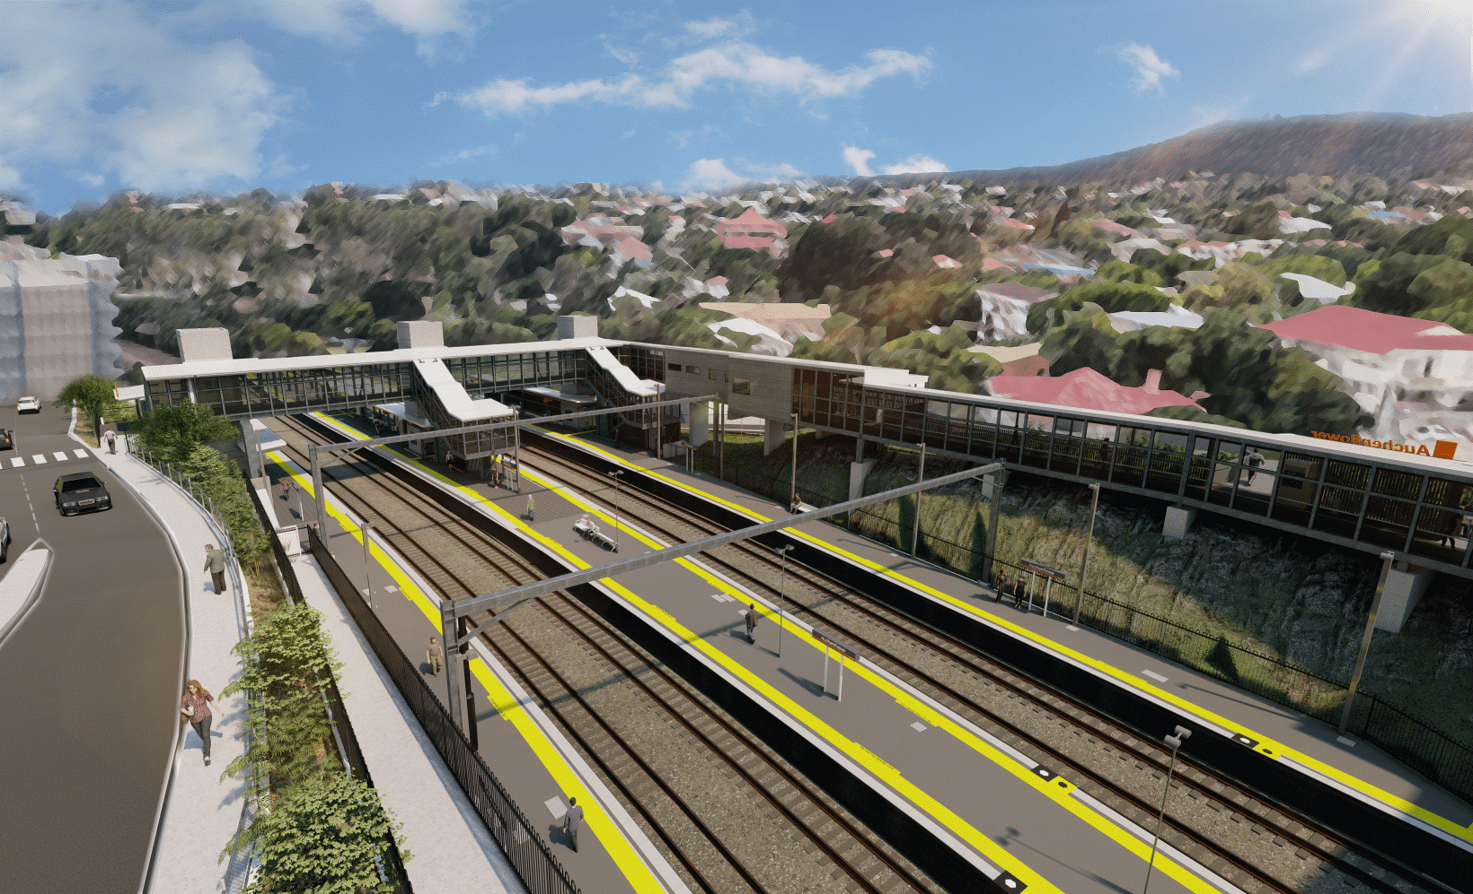
Auchenflower station accessibility upgrade

WORKS NOTICE

Night and after hours works
July 2022

As part of the Auchenflower station accessibility upgrade, Queensland Rail will undertake after hours works on selected nights in July (6pm to 6am the next day).
In addition, around-the-clock works will be undertaken from 6pm Friday 22 until 6am Monday 25 July, during a scheduled weekend track closure when buses will replace trains.
The station’s new footbridge will be closed for works over the weekend of Saturday 23 and Sunday 24 July and there will be no cross-corridor pedestrian access. During this time, a free accessible shuttle (maxi taxi) will operate between Eagle Terrace and Lang Parade to transport customers and pedestrians around the footbridge closure.
For safety, these works have been scheduled at night or during a weekend track closure when rail traffic is reduced and there are fewer people around the station and hospital precincts.
To support site access and construction activity, Auchenflower Terrace will be closed between McIlwraith Street and Ridley Street with a diversion via McIlwraith Street and Harriett Street. Motorists are requested to follow the instructions of the traffic controllers and drive to the changed conditions.
Residents near the station may experience noise associated with construction activity and truck movements. Every effort will be made to minimise disruption and we thank you for your patience during these important works.

Overview of works (weather and construction conditions permitting)
Queensland Rail Limited ABN 71 132 181 090
Location | Dates and hours of work | Type of work
Auchenflower station, carpark and rail corridor  Surrounding local streets (including Auchenflower Terrace closed)  Footbridge closed Saturday 23 and Sunday 24 July | Night works in July  6pm to 6am the next day on:  - Monday 4 July  - Wednesday 6 July  - Monday 11 July  - Wednesday 13 July  - Monday 18 July  - Wednesday 20 July  - Monday 25 July  - Wednesday 27 July  (eight separate nights in the month)  During weekend track closure  - 6pm Friday 22 to 6am Monday 25 July  (continuous, around-the-clock works) | Station upgrade activities involving:  - excavation and removal of spoil by truck  - construction of retaining walls  - concrete pumping and concrete works  - footpath reinstatement works  - installation of structural steel  - establishment, operation and demobilisation of large crane (for footbridge lift 23 and 24 July)  - operation of machinery and heavy equipment  - use of hand-held tools and powered equipment  - delivery and unloading of materials by truck  - movement of vehicles and machinery with flashing lights and reversing beepers  - portable lighting towers in use at night  - road closure (Auchenflower Terrace) with traffic diversion.
The Auchenflower station accessibility upgrade is part of the State Government’s ongoing investment of more than $500 million to upgrade stations across the South East Queensland network, making them accessible for all customers. For more information, please contact the project’s community team on free call 1800 722 203 or email stationsupgrade@qr.com.au
Sign up for electronic notifications at queenslandrail.com.au/EmailNotification

