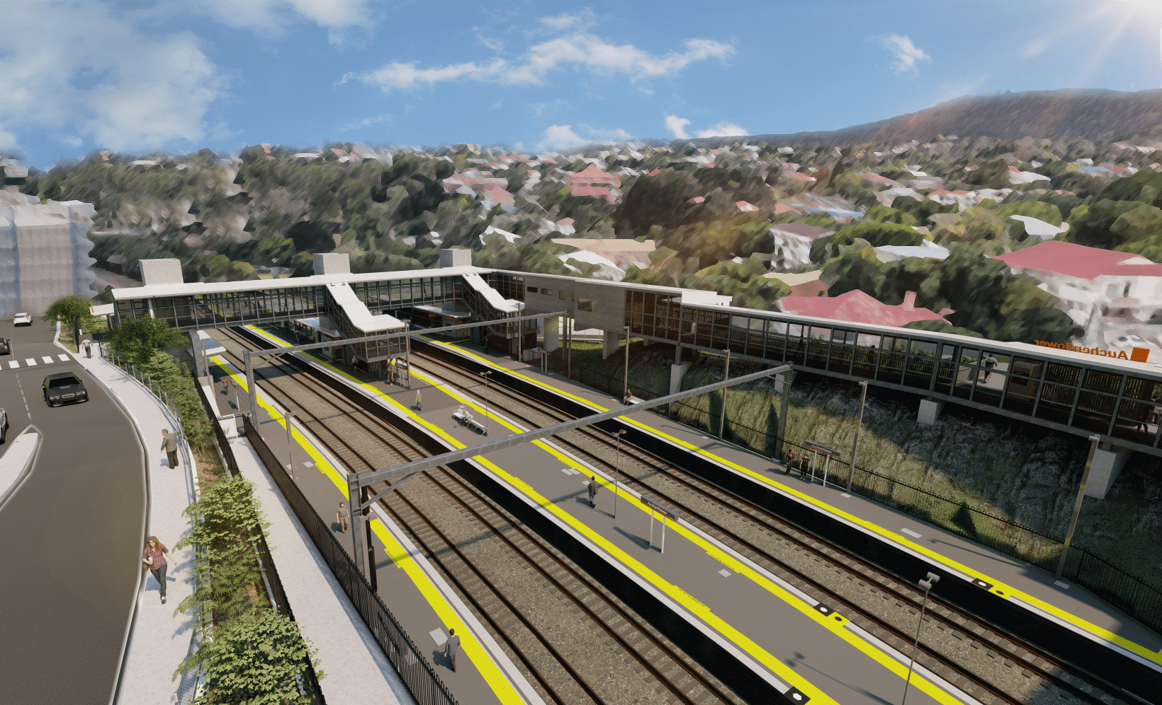
Auchenflower station accessibility upgrade

WORKS NOTICE

Night works
June 2021

As part of the Auchenflower station accessibility upgrade, Queensland Rail will undertake a program of night works in June 2021 (weather and construction conditions permitting).
These works can only be scheduled after hours when rail traffic is reduced and there are fewer people around the station precinct.
To support these night works there may be some lane closures (under traffic control) on Lang Parade and Auchenflower Terrace.
Residents near the station may experience some noise associated with construction activity and the operation of excavators, trucks and equipment around the work zone.
Every effort will be made to minimise disruption and we thank you for your patience during these important works.

Overview of works
Location | Dates and hours of work | Type of work  Queensland Rail Limited ABN 71 132 181 090
Auchenflower station, platforms, carpark and rail corridor  Lang Parade, Auchenflower Terrace | 8pm to 6am the next day on:  - Tuesday 8 June  - Wednesday 9 June  - Monday 14 June  - Tuesday 15 June  - Wednesday 16 June  - Thursday 17 June  - Friday 18 June  - Saturday 19 June  (over eight nights) | Station upgrade activities involving:  - excavation and removal of spoil  - platform works  - operation of machinery and movement of trucks and vehicles with flashing lights and reversing beepers  - use of hand-held tools and powered equipment  - portable lighting towers in use at night  - lane closures with traffic management – Lang Parade and Auchenflower Terrace.
The Auchenflower station accessibility upgrade is part of the State Government’s ongoing investment of more than $500 million to upgrade stations across the South East Queensland network, making them accessible for all customers.
For more information, please contact the project’s community team on free call 1800 722 203 or email stationsupgrade@qr.com.au

