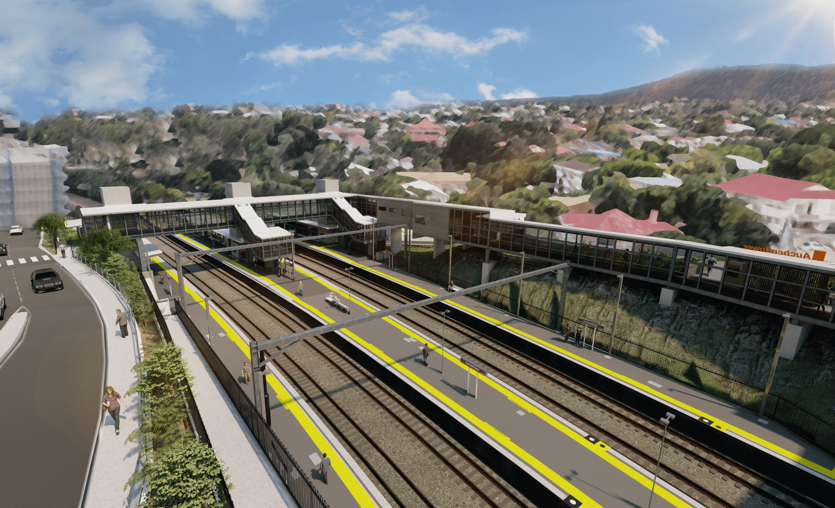
Auchenflower station accessibility upgrade

WORKS NOTICE

Night works
June 2021

As part of the Auchenflower station accessibility upgrade, Queensland Rail will undertake night works (8pm to 5am the next day, Monday to Friday) over two weeks from Monday 21 June to Friday 2 July 2021. These works are a continuation of those previously notified for the month of June and they can only be undertaken after hours when rail traffic is reduced and there are fewer people around the station precinct.
To support these works, there may be single-lane closures (under traffic control) on Auchenflower Terrace and Lang Parade on selected dates.
Residents near the station may experience some noise associated with construction activity and the operation of excavators, cranes, concrete pumping trucks and equipment around the work zone. Every effort will be made to minimise disruption and we thank you for your patience during these important works.

Overview of works
Queensland Rail Limited ABN 71 132 181 090
Location | Dates and hours of work | Type of work
Auchenflower station, carpark and rail corridor  Station subway (closed during concrete pours)  Auchenflower Terrace and Lang Parade (lane closures) | 8pm to 5am the next day on:  - Monday 21 to Friday 25 June  - Monday 28 June to Friday 2 July  (10 nights over two weeks) | Station upgrade activities involving:  - excavation and removal of spoil  - bored piling (drilling) – foundations for new footbridge and stairs  - concrete pours  - platform works  - operation of cranes, concrete trucks and movement of vehicles and machinery with flashing lights and reversing beepers  - use of hand-held tools and powered equipment  - portable lighting towers in use at night  - single-lane closures under traffic control, as required (Auchenflower Terrace and Lang Parade).
The Auchenflower station accessibility upgrade is part of the State Government’s ongoing investment of more than $500 million to upgrade stations across the South East Queensland network, making them accessible for all customers.
For more information, please contact the project’s community team on free call 1800 722 203 or email stationsupgrade@qr.com.au

