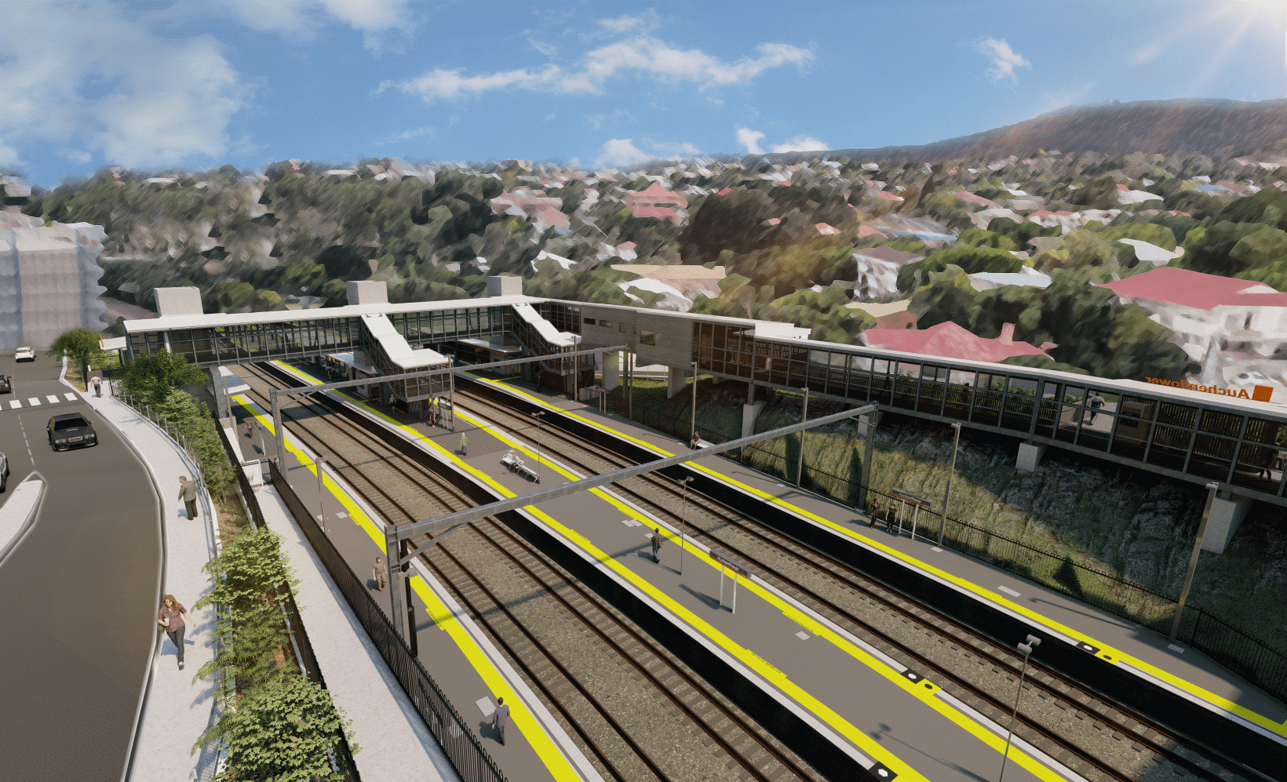
Auchenflower station accessibility upgrade

WORKS NOTICE

Night and after hours works
May 2022

As part of the Auchenflower station accessibility upgrade, Queensland Rail will undertake after hours works on selected nights in May.
For safety, these works can only be undertaken after hours when rail traffic is reduced and there are fewer people around the station or hospital precincts.
Some night activities are a continuation of activities previously notified or already commenced. These include upgrading the pedestrian crossing on Lang Parade and abutment works for the new footbridge to be installed in May.
Around-the-clock weekend works will be undertaken during a scheduled track closure from 6pm Friday 20 until 6am Monday 23 May.
Lane closures and traffic management in Lang Parade (near the work zones), may be required to support deliveries, concrete trucks and construction activities.
Residents near the station may experience noise associated with trucks movements and construction activity. Every effort will be made to minimise disruption and we thank you for your patience during these important works.

Overview of works (weather and construction conditions permitting)
Queensland Rail Limited ABN 71 132 181 090
Location | Dates and hours of work | Type of work
Auchenflower station, carpark and rail corridor  Lang Parade – pedestrian crossing (between Chasely Street and the hospital carpark) | Selected night works:  6pm to 6am the next day on:  - Thursday 28 and Friday 29 April (previously notified)  - Tuesday 3 to Thursday 5 May  - Monday 9 to Friday 13 May  - Tuesday 17 to Thursday 19 May.  (overnight works)  Around-the-clock weekend works:  - 6pm Friday 6 to 6am Monday 9 May (Lang Parade crossing)  - 6pm Friday 20 to 6am Monday 23 May (during scheduled weekend track closure). | Station upgrade activities involving:  - bridge abutment screw piling (drilling)  - operation of concrete pumping trucks  - roadworks, linemarking and asphalting (Lang Parade pedestrian crossing, 6 to 9 May)  - platform raising works including excavation (20 to 23 May, during track closure)  - operation of machinery and heavy equipment  - movement of vehicles and machinery with flashing lights and reversing beepers  - use of hand-held tools and powered equipment  - portable lighting towers in use at night  - lane closures (Lang Parade) with traffic management (if/as required).
The Auchenflower station accessibility upgrade is part of the State Government’s ongoing investment of more than $500 million to upgrade stations across the South East Queensland network, making them accessible for all customers. For more information, please contact the project’s community team on free call 1800 722 203 or email stationsupgrade@qr.com.au
Sign up for electronic notifications at queenslandrail.com.au/EmailNotification

