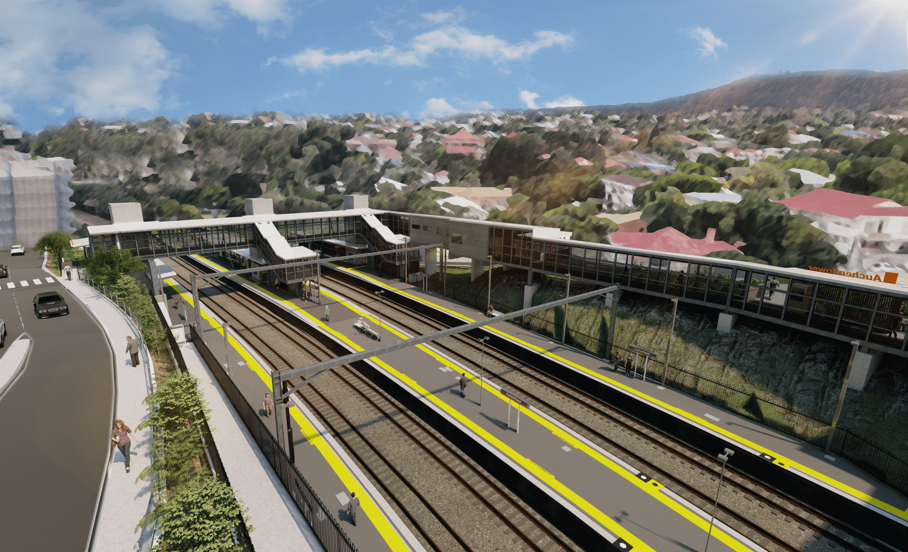
Auchenflower station accessibility upgrade

WORKS NOTICE

Night works
Monday 29 November to Wednesday 1 December 2021

As part of the Auchenflower station accessibility upgrade, Queensland Rail will undertake excavation works over three nights from Monday 29 November to Wednesday 1 December, 8pm to 5am the next day (weather and construction conditions permitting).
Activities will involve a vacuum excavation truck positioned in Lang Parade behind platform 1 (hospital side of the station).
For safety, these works can only be undertaken after hours when there is reduced rail traffic and fewer people around the station and Wesley Hospital precincts.
A lane closure, under traffic management, will be in place in Lang Parade near the hospital carpark entrance.
Residents near the station may experience noise associated with the operation of the vacuum excavation truck and the movement of project vehicles around the work zone.
Every effort will be made to minimise disruption and we thank you for your understanding during these important works.

Overview of works
Location | Dates and hours of work | Type of work
Auchenflower station and rail corridor  Lang Parade (lane closure and traffic management) | 8pm to 5am the next day on:  - Monday 29 November  - Tuesday 30 November  - Wednesday 1 December  (over three nights) | Excavation behind platform 1 (Lang Parade side) involving:  - operation of a vacuum excavation truck  - operation of vehicles and machinery with flashing lights and reversing beepers  - use of hand-held tools and powered equipment  - portable lighting towers in use at night  - lane closure and traffic management – Lang Parade.
The Auchenflower station accessibility upgrade is part of the State Government’s ongoing investment of more than $500 million to upgrade stations across the South East Queensland network, making them accessible for all customers.
For more information, please contact the project’s community team on free call 1800 722 203 or email stationsupgrade@qr.com.au

Sign up for electronic notifications at queenslandrail.com.au/EmailNotification

