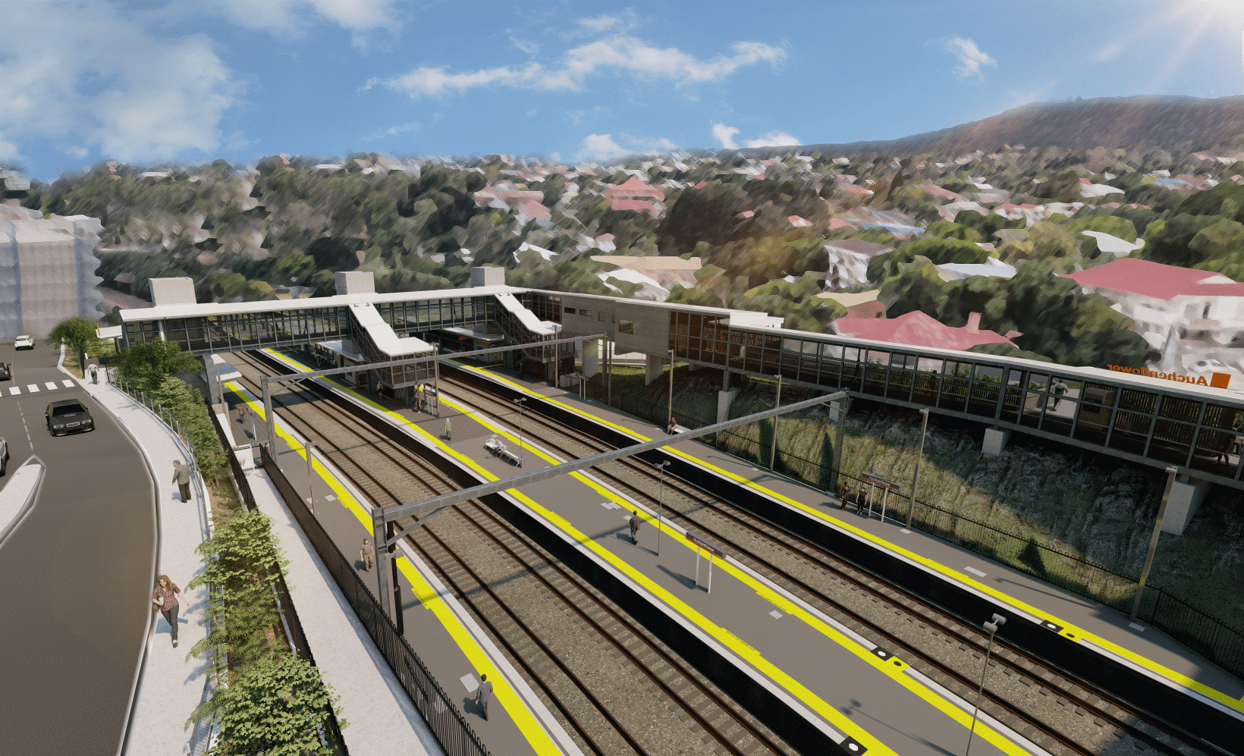
Auchenflower station accessibility upgrade

WORKS NOTICE

Night works
October/November 2021

As part of the Auchenflower station accessibility upgrade, Queensland Rail will undertake weeknight works (8pm to 5am the next day, excluding public holidays) during October and November 2021 (weather and construction conditions permitting). These works are a continuation of after hours activities previously notified for September and October.
Following this period of night works, around-the-clock works will be undertaken at the station during a scheduled track closure, from 8pm Friday 12 until 5am Monday 15 November 2021.
For safety, these works can only be undertaken after hours when there is reduced rail traffic and fewer people around the station and Wesley Hospital precincts.
Residents near the station may experience noise associated with construction activity and the operation of trucks and heavy equipment around the work zone. As required, works may involve lane closures and traffic management (Lang Parade and Auchenflower Terrace). Every effort will be made to minimise disruption and we thank you for your understanding during these important works.

Overview of works
Location | Dates and hours of work | Type of work
Auchenflower station and rail corridor  Auchenflower Terrace and Lang Parade (lane closures and traffic management, as required) | Weeknight works:  8pm to 5am the next day on:  - Monday 18 to Friday 22 October  - Monday 25 to Thursday 28 October  - Monday 1 to Friday 5 November  - Monday 8 to Thursday 11 November  (18 nights over four weeks, excluding weekends and public holidays)  Works during track closure:  8pm Friday 12 to 5am Monday 15 November  (continuous, around-the-clock works) | Station upgrade activities involving:  - stormwater pipe installation  - electrical/communications installations  - structural steel installation  - concrete pours  Queensland Rail Limited ABN 71 132 181 090  - materials delivery to island platform 2/3  - preparation works for platform-raising during track closure  - operation of cranes, concrete pumping trucks, vehicles and machinery with flashing lights and reversing beepers  - use of hand-held tools and powered equipment  - portable lighting towers in use at night  - traffic management (as required) – Lang Parade and Auchenflower Terrace.
The Auchenflower station accessibility upgrade is part of the State Government’s ongoing investment of more than $500 million to upgrade stations across the South East Queensland network, making them accessible for all customers.
For more information, please contact the project’s community team on free call 1800 722 203 or email stationsupgrade@qr.com.au
Sign up for electronic notifications at queenslandrail.com.au/EmailNotification

