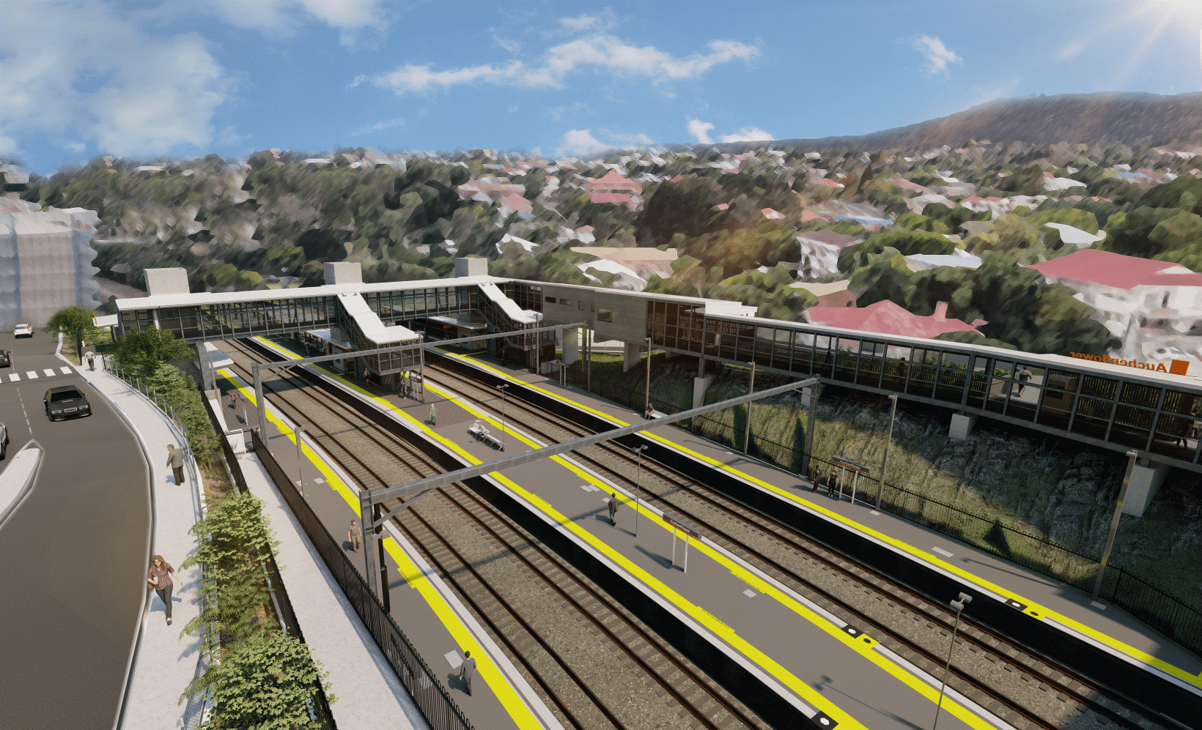
Auchenflower station accessibility upgrade

WORKS NOTICE

Night works
September/October 2021

As part of the Auchenflower station accessibility upgrade, Queensland Rail will undertake weeknight works (8pm to 5am the next day, excluding public holidays) between Monday 27 September and Friday 8 October (weather and construction conditions permitting).
These works are a continuation of after hours activities previously notified for September.
Residents near the station may experience some noise associated with construction activity and the operation of trucks and heavy equipment around the work zone.
The current full road closure on Auchenflower Terrace, between Dixon Street and Ridley Street, will be in place until Friday 29 October 2021.
Every effort will be made to minimise disruption and we thank you for your understanding during these important works.

Overview of works
Location | Dates and hours of work | Type of work
Auchenflower station and rail corridor  Auchenflower Terrace (full road closure) | 8pm to 5am the next day on:  - Monday 27 September to Friday 1 October  - Tuesday 5 to Friday 8 October  (over nine separate nights) | Station upgrade activities involving:  - stormwater pipe installation  - excavation, rock-breaking and removal of spoil  Queensland Rail Limited ABN 71 132 181 090  - operation of cranes, concrete trucks and heavy equipment  - movement of vehicles and machinery with flashing lights and reversing beepers  - use of hand-held tools and powered equipment  - portable lighting towers in use at night  - road closure and traffic management (Auchenflower Terrace).
The Auchenflower station accessibility upgrade is part of the State Government’s ongoing investment of more than $500 million to upgrade stations across the South East Queensland network, making them accessible for all customers.
For more information, please contact the project’s community team on free call 1800 722 203 or email stationsupgrade@qr.com.au

Sign up for electronic notifications at queenslandrail.com.au/EmailNotification

