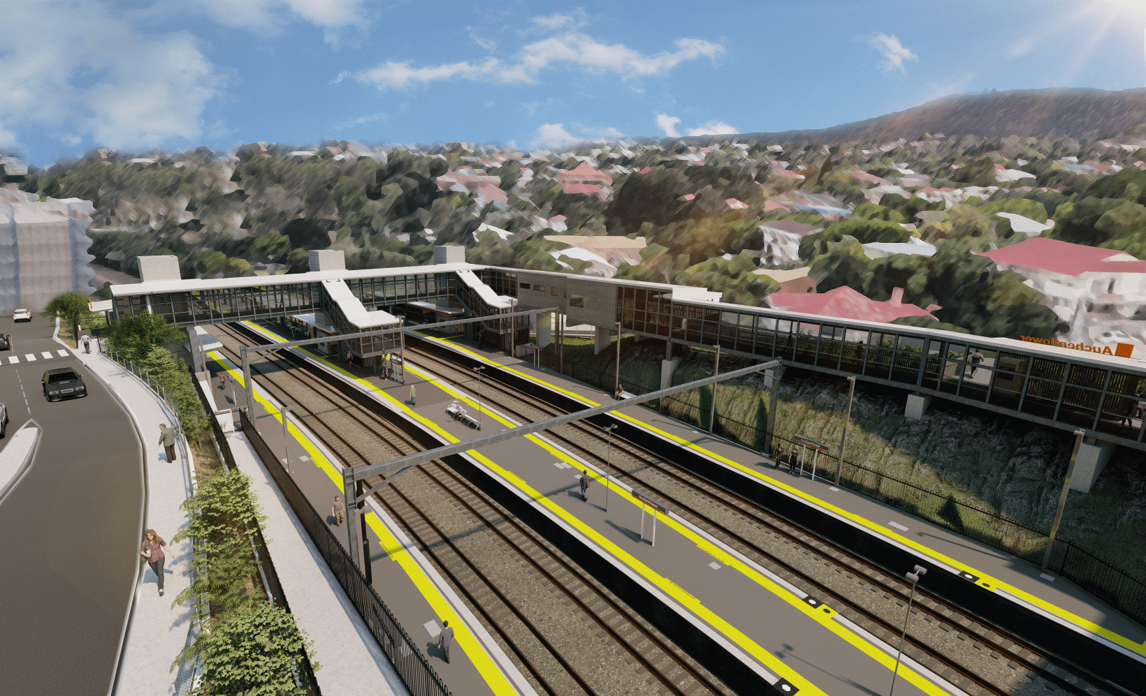
Auchenflower station accessibility upgrade

WORKS NOTICE

Night and weekend works
February and March 2022

In addition to previously advised after hours works for the Auchenflower station accessibility upgrade, Queensland Rail will undertake night and weekend works on selected weekends in February and March.
Steelwork and stairs will be installed for the new Lang Parade station entrance on Saturday 26 and Sunday 27 February and a new pedestrian crossing will be constructed on Lang Parade on Saturday 5 and Sunday 6 March.
These works can only be undertaken out of hours to minimise the impact on Wesley Hospital operations and when there are fewer people around the station precinct.
Residents near the station may experience noise associated with construction activity and the operation trucks and heavy machinery around the work zone. Every effort will be made to minimise disruption and we thank you for your continued patience during these important works.
On each of these weekends a full road closure of Lang Parade will be in place. All access to The Wesley Hospital carpark will be via Patrick Lane. Motorists are advised to follow the instructions of the traffic controllers and drive to the changed conditions.

Overview of works (weather and construction conditions permitting)
Queensland Rail Limited ABN 71 132 181 090
Location | Dates and hours of work | Type of work
Auchenflower station and rail corridor  Lang Parade, near hospital carpark (road closure with traffic management) | Weekend and night works:  6pm until 6am the next day on:  - Saturday 26 February  - Sunday 27 February  - Saturday 5 March  - Sunday 6 March  (day shifts and overnight works, in addition to previously notified works)  Lang Parade full road closures:  - 8pm Friday 25 to 6am Monday 28 February  - 8pm Friday 4 to 6am Monday 7 March | Station upgrade activities involving:  - installation of stairs – Lang Parade entrance (26 and 27 February)  - construction of pedestrian crossing, Lang Parade (5 and 6 March)  - the movement of trucks and machinery with flashing lights and reversing beepers  - delivery and unloading of steel work (Lang Parade)  - operation of heavy machinery, hand-held tools and powered equipment portable lighting towers in use at night  - road closure (Lang Parade) and traffic diversion to hospital carpark.
The Auchenflower station accessibility upgrade is part of the State Government’s ongoing investment of more than $500 million to upgrade stations across the South East Queensland network, making them accessible for all customers.
For more information, please contact the project’s community team on free call 1800 722 203 or email stationsupgrade@qr.com.au
Sign up for electronic notifications at queenslandrail.com.au/EmailNotification

