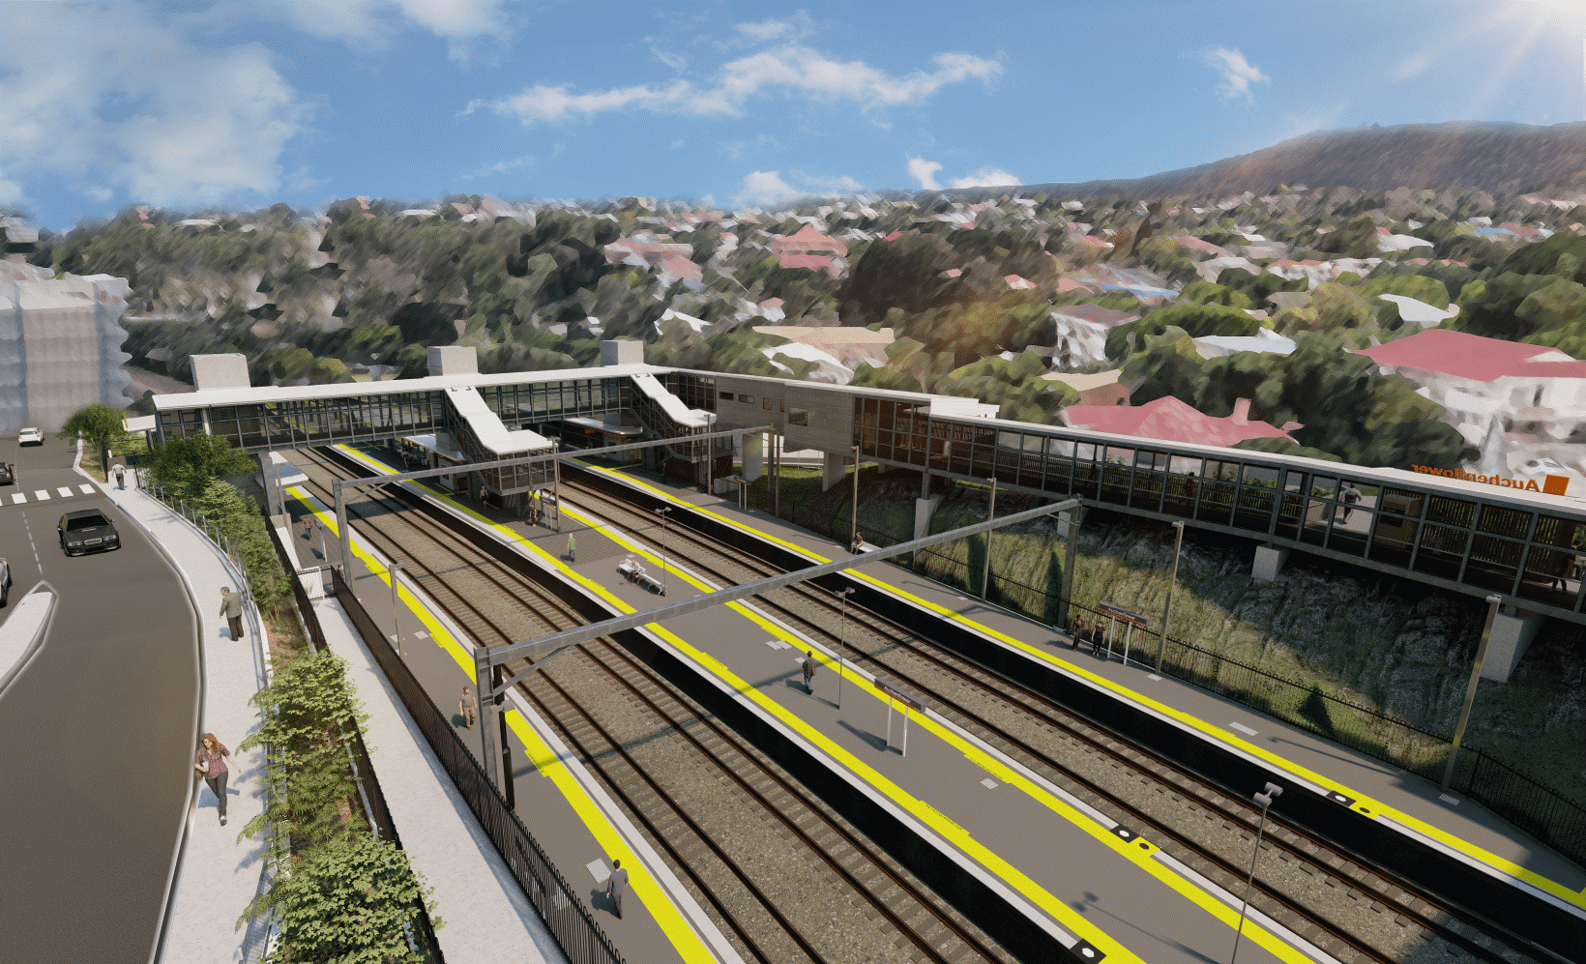
Auchenflower station accessibility upgrade

WORKS NOTICE

Full road closure – Auchenflower Terrace
8pm Friday 28 to 5am Monday 31 May 2021

As part of the Auchenflower station accessibility upgrade, Queensland Rail will undertake continuous (around-the-clock) works from 8pm Friday 28 until 5am Monday 31 May.
To support these important works, Auchenflower Terrace will be closed during this time between McIlwraith Street and Ridley Street, with a traffic diversion via McIlwraith Street, Harriett Street and Ridley Street.
Motorists are requested to follow the instructions of the traffic controllers and drive to the changed traffic conditions.
Pedestrian access on Auchenflower Terrace will be maintained on the residential (or western) side of the street.
Residents along the detour route may experience increased traffic and associated noise over this weekend.
Residents near the station may experience some noise associated with construction activity and the operation of excavators, cranes, concrete pumping trucks and equipment around the work zone.
Every effort will be made to minimise disruption and we thank you for your patience during these important works.
Queensland Rail Limited ABN 71 132 181 090

Overview of works (weather and construction conditions permitting)
Location | Dates and hours of work | Type of work
Auchenflower Terrace (between McIlwraith Street and Ridley Street) | Full road closure to support weekend works:  8pm Friday 28 to 5am Monday 31 May | Traffic management:  - full road closure with traffic diversion via McIlwraith, Harriett and Ridley Streets  - single-lane closures under traffic control at other times, as required (Auchenflower Terrace and Lang Parade).

The Auchenflower station accessibility upgrade is part of the State Government’s ongoing investment of more than $500 million to upgrade stations across the South East Queensland network, making them accessible for all customers.
For more information, please contact the project’s community team on free call 1800 722 203 or email stationsupgrade@qr.com.au

