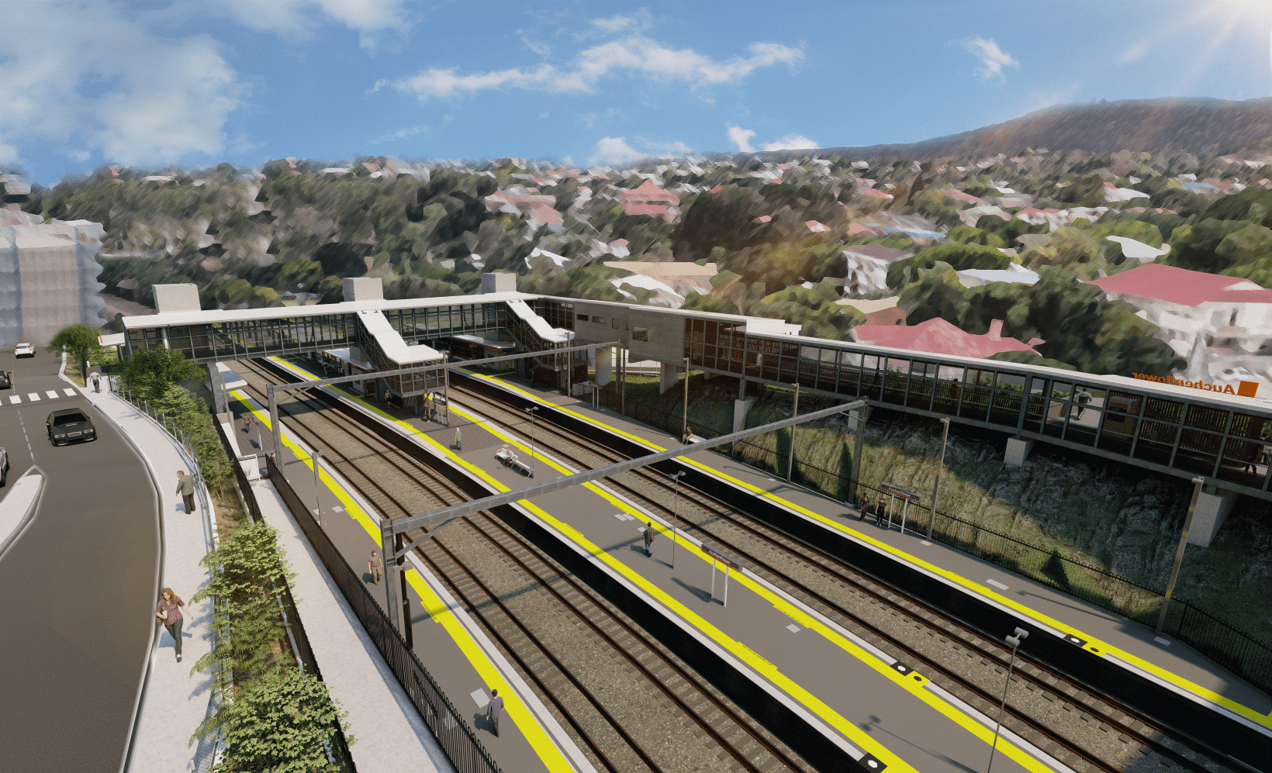
Auchenflower station accessibility upgrade

WORKS NOTICE

Full road closure – Auchenflower Terrace
3pm Thursday 19 to 6am Monday 23 May 2022
To support construction works for the Auchenflower station accessibility upgrade, Auchenflower Terrace will be closed, between McIlwraith Street and Ridley Street, from 3pm Thursday 19 until 6am Monday 23 May 2022 (weather and construction conditions permitting).
This full road closure will enable the safe establishment and operation of a large crane, located at the corner of Auchenflower Terrace and Ridley Street, to install a new pedestrian footbridge on the weekend of 21 and 22 May 2022 (works previously notified). These activities represent a key step in project delivery.
A traffic diversion via McIlwraith Street, Harriett Street and Ridley Street will be in place. Motorists are requested to follow the instructions of the traffic controllers and drive to the changed traffic conditions.
Pedestrian access on Auchenflower Terrace will be provided on the residential (or western) side of the street. For public safety (eg. during crane operation), pedestrian access in Auchenflower Terrace may be temporarily restricted as required.
Access to private property will be maintained at the instruction of the traffic controller.
Residents along the detour and near the work zones may experience increased traffic and noise associated with construction activity, the movement of trucks and the operation of cranes and heavy equipment.
Every effort will be made to minimise disruption and we apologise for any inconvenience as we undertake these important works.

Overview of works (weather and construction conditions permitting)
Queensland Rail Limited ABN 71 132 181 090
Location | Dates and hours of works | Type of work
Auchenflower Terrace (between McIlwraith Street and Ridley Street) | Full road closure:  3pm Thursday 19 to 6am Monday 23 May | Traffic management supporting station upgrade works:  - full road closure with traffic diversion via McIlwraith, Harriett and Ridley Streets  - earthworks – construction of a crane pad  - installation and operation of a large crane (corner of Auchenflower Terrace and Ridley Street)  - crane lift (weekend of 21 and 22 May).
The Auchenflower station accessibility upgrade is part of the State Government’s ongoing investment of more than $500 million to upgrade stations across the South East Queensland network, making them accessible for all customers.
For more information, please contact the project’s community team on free call 1800 722 203 or email stationsupgrade@qr.com.au
Sign up for electronic notifications at queenslandrail.com/EmailNotification

