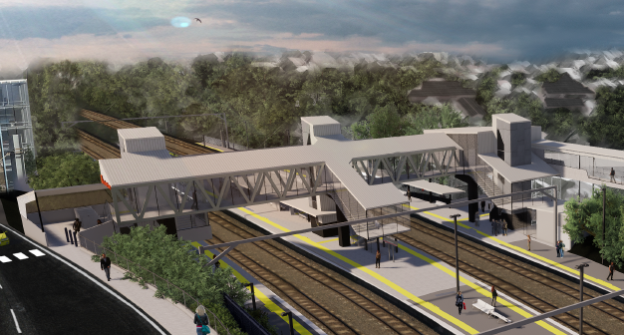
Auchenflower station accessibility upgrade

WORKS NOTICE

Weekend works and road closure
1am Saturday 13 to 5am Monday 15 February 2021

As part of the Auchenflower station accessibility upgrade, Queensland Rail will undertake around-the-clock works from 1am Saturday 13 until 5am Monday 15 February 2021 (weather and construction conditions permitting). These works have been planned during a scheduled track closure.
Over this weekend, Auchenflower Terrace will be closed, 6am to 6pm Saturday and Sunday, between McIlwraith Street and Ridley Street with a traffic diversion via McIlwraith and Harriett Streets. Motorists are requested to follow the instruction of the traffic controllers and drive to the changed conditions. Access to private property will be maintained. At times, Lang Parade will have traffic control in operation for safety.
Residents near the station may experience some noise associated with construction activity, the operation of machinery and the movement of vehicles and equipment around the work zone. Every effort will be made to minimise disruption and we apologise for any inconvenience as we build you a better Auchenflower station.

Overview of weekend works
Queensland Rail Limited ABN 71 132 181 090
Location | Dates and hours of work | Type of work
Auchenflower station, platforms, subway and carpark (closed)  Station concourse (open)  Rail corridor access gates (near Dixon Street/Patrick Lane, Eagle Terrace/Cue Street and Lang Parade)  Auchenflower Terrace (road closure) | 1am Saturday 13 to 5am Monday 15 February  (continuous works)  Auchenflower Terrace road closure, 6am to 6pm Saturday and Sunday | Station upgrade construction works involving:  - operation of cranes, excavators, trucks, on-track vehicles and machinery with flashing lights and reversing beepers  - partial platform raising/concreting (platform 1)  - stormwater works (platform 2/3)  - screw piling (drilling) foundations (platform 4)  - use of saws, hand-held and powered equipment  - movement of personnel and vehicles around the station and in the rail corridor  - portable lighting towers in use at night  - road closure (Auchenflower Terrace) with diversion via McIlwraith and Harriett Streets  - traffic control (Lang Parade).
The Auchenflower station accessibility upgrade is part of the State Government’s investment of more than $500 million to upgrade stations across the South East Queensland network, making them accessible for all customers. For more information, please contact the project’s community team on free call 1800 722 203 or email stationsupgrade@qr.com.au

