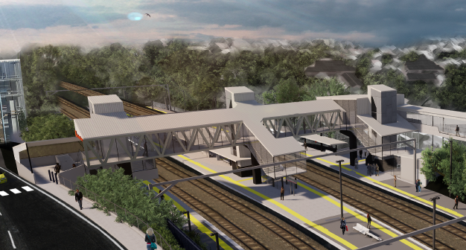
Auchenflower station accessibility upgrade

WORKS NOTICE

Weekend works and road closure
1am Saturday 14 to 5am Monday 16 November 2020

As part of the Auchenflower station accessibility upgrade, Queensland Rail will undertake around-the-clock works from 1am Saturday 14 until 5am Monday 16 November 2020 (continuous works, weather and construction conditions permitting). These works have been planned during a scheduled closure of the Ipswich line.
Over this weekend, Auchenflower Terrace will be closed between McIlwraith Street and Ridley Street with a traffic diversion via McIlwraith and Harriett Streets. Motorists are requested to follow the instruction of the traffic controllers and drive to the changed conditions. Access to private property will be maintained.
Residents near the station may experience some noise associated with construction activity, the operation of machinery and the movement of vehicles and equipment around the work zone.
Every effort will be made to minimise disruption and we apologise for any inconvenience as we build you a better Auchenflower station.

Overview of weekend works
Queensland Rail Limited ABN 71 132 181 090
Location | Dates and hours of work | Type of work
Auchenflower station, platforms, subway and carpark (closed)  Station concourse (open)  Auchenflower Terrace (road closure)  Rail corridor access gates (near Dixon Street, Eagle Terrace/Cue Street and Lang Parade) | 1am Saturday 14 to 5am Monday 16 November  (continuous works) | Station upgrade construction works involving:  - operation of cranes, excavators, trucks, on-track vehicles and machinery with flashing lights and reversing beepers  - use of saws, hand-held tools and powered equipment  - movement of personnel and vehicles around the station and in the rail corridor  - portable lighting towers in use at night  - traffic management (Auchenflower Terrace) with diversion via McIlwraith and Harriett Streets.
The Auchenflower station accessibility upgrade is part of Queensland Rail’s program to upgrade stations across the South East Queensland network, making them accessible for all customers.
For more information, please contact the project’s community team on free call 1800 722 203 or email stationsupgrade@qr.com.au

