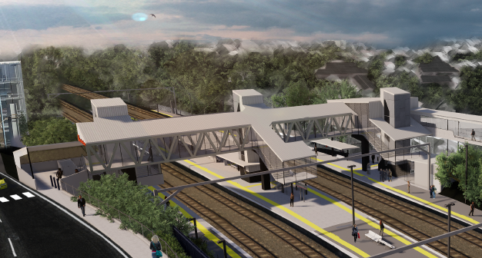
Auchenflower station accessibility upgrade

WORKS NOTICE

Weekend track and overhead works
8pm Friday 22 to 5am Monday 25 January 2021
As part of the Auchenflower station accessibility upgrade, Queensland Rail will undertake supporting track and overhead line works during a scheduled track closure, with continuous works undertaken from 8pm Friday 22 until 5am Monday 25 January 2021 (weather and construction conditions permitting).
These critical works have been scheduled when there is no rail traffic and the power to the overhead lines can be switched off.
For safety during works, there will be a lane closure with traffic control on Eagle Terrace and also traffic control on Dixon Street. The station’s customer carpark will be closed.
Residents near the station may experience some noise associated with construction activity and the operation of vehicles and equipment around the work zone. Every effort will be made to minimise disruption and we thank you for your patience while we build you a better Auchenflower station.

Overview of works
Queensland Rail Limited ABN 71 132 181 090
Location | Dates and hours of work | Type of work
Auchenflower station, carpark and rail corridor  Rail corridor access gates (near Dixon Street and Eagle Terrace/Cue Street) | 8pm Friday 22 to 5am Monday 25 January 2021  (continuous works) | Track and overhead infrastructure activities involving:  - cutting/welding rail and moving ballast (rock)  - relocation/installation of steel masts and overhead line equipment and removal of old mast foundations (rock breaking and concrete cutting)  - operation of cranes, trucks, on-track vehicles and machinery with flashing lights and reversing beepers  - hand-held tools and powered equipment  - movement of personnel and vehicles around the station and in the rail corridor  - lane closure and traffic control (Eagle Terrace and Dixon Street)  - portable lighting towers in use at night.
The Auchenflower station accessibility upgrade is part of the State Government’s ongoing investment of more than $500 million to upgrade stations across the South East Queensland network, making them accessible for all customers. For more information, please contact the project’s community team on free call 1800 722 203 or email stationsupgrade@qr.com.au

