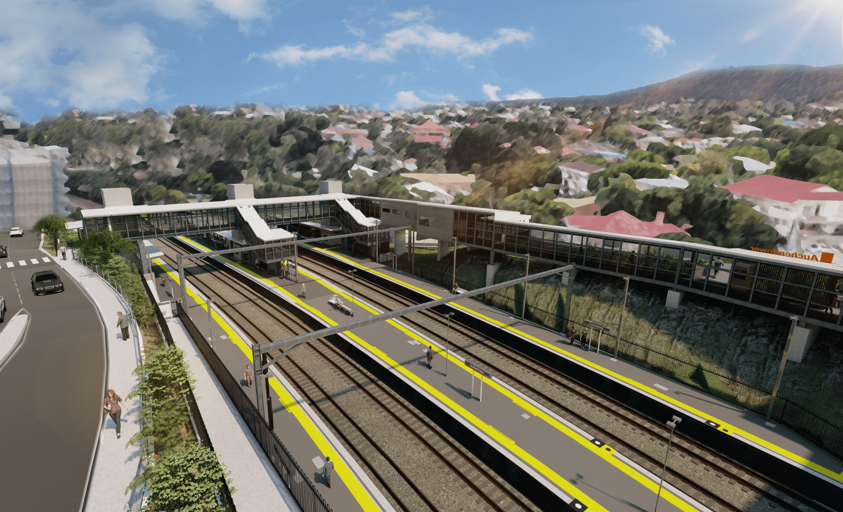
Auchenflower station accessibility upgrade

WORKS NOTICE

After hours weekend works
6pm Friday 11 to 6am Monday 14 March 2022

As part of the Auchenflower station accessibility upgrade, Queensland Rail will undertake weekend and night works from 6pm Friday 11 until 6am Monday 14 March to commence the construction of a large crane near the corner of Auchenflower Terrace and Ridley Street. For safety, these works can only be undertaken after hours when rail traffic is reduced and there are fewer people around the station precinct.
Due to the impacts to the program of the recent flood and clean-up activity, some works have been rescheduled to prepare for the bridge removal planned for the weekend 19 and 20 March during a scheduled track closure (previously notified). We apologise for this late change to the program.
Traffic management may be required to support site access and other construction activities. Auchenflower Terrace is currently closed for construction works until 6pm Saturday 2 April. Motorists are advised to follow the instructions of the traffic controllers and drive to the changed conditions.
Residents near the station may experience noise associated with trucks movements and construction activity around the work zone. Every effort will be made to minimise disruption and we thank you for your patience during these important works.

Overview of works (weather and construction conditions permitting)
Queensland Rail Limited ABN 71 132 181 090
Location | Dates and hours of work | Type of work
Auchenflower station, carpark and rail corridor  Surrounding local streets (Auchenflower Terrace, Ridley Street, Eagle Terrace, Lang Parade) | Night and weekend works:  6pm Friday 11 to 6am Monday 14 March  (around-the-clock works over the weekend)  Note: Crane construction will continue through the next week.  Reminder (previously notified):  During weekend track closure:  - 6pm Friday 18 to 6am Monday 21 March  (around-the-clock works) | Station upgrade activities involving:  - installation of a crane pad (earthworks)  - delivery and unloading of crane components by truck  - construction of large crane for station building/concourse removal  - operation of machinery and heavy equipment  - the movement of vehicles and machinery with flashing lights and reversing beepers  - use of hand-held tools and powered equipment  - portable lighting towers in use at night  - road closure (Auchenflower Terrace), lane closures and traffic management (as required).
The Auchenflower station accessibility upgrade is part of the State Government’s ongoing investment of more than $500 million to upgrade stations across the South East Queensland network, making them accessible for all customers.
For more information, please contact the project’s community team on free call 1800 722 203 or email stationsupgrade@qr.com.au
Sign up for electronic notifications at queenslandrail.com.au/EmailNotification

