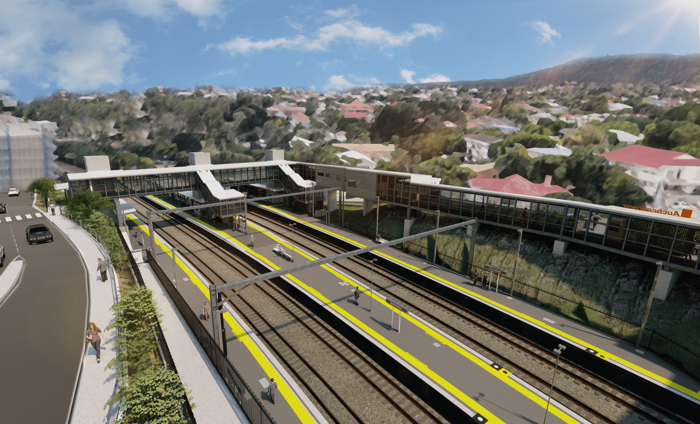
Auchenflower station accessibility upgrade

WORKS NOTICE

Night and weekend works including road closures
July/August 2021

As part of the Auchenflower station accessibility upgrade, Queensland Rail will undertake night works (8pm to 5am the next day) on selected dates between Thursday 29 July and Thursday 12 August.
Following this program of nights, around-the-clock weekend works will be undertaken from 8pm Friday 13 until 5am Monday 16 August. Train services will be unaffected by the weekend’s works.
These works can only be undertaken after hours when rail traffic is reduced and there are fewer people around the station precinct.
Lang Parade will be closed (between Chasely Street and The Wesley Hospital public carpark) from 8pm Friday 13 to 5am Monday 16 August with access to the hospital carpark via Patrick Lane (see map over the page for traffic changes). Auchenflower Terrace (between Dixon Street and Ridley Street) will be closed until late October.
Residents near the station may experience noise associated with construction activity and the operation of excavators, cranes, elevated work platforms, concrete trucks and equipment around the work zone. Every effort will be made to minimise disruption and we thank you for your patience during these important works.

Overview of works (weather and construction conditions permitting)
Location | Dates and hours of work | Type of work
Auchenflower station and rail corridor  Auchenflower Terrace (currently closed)  Lang Parade (closed at corner Chasely Street, 13 to 16 August – see map page 2) | Night works in July and August:  8pm to 5am the next day on:  - Thursday 29 July  - Friday 30 July  - Tuesday 3 August  - Wednesday 4 August  - Thursday 5 August  - Tuesday 10 August  - Thursday 12 August  (on seven separate nights)  Weekend works:  8pm Friday 13 to 5am Monday 16 August  (continuous, around-the-clock works) | Station upgrade activities involving:  - excavation and removal of spoil  - platform works and concrete pours  Queensland Rail Limited ABN 71 132 181 090  - installation of lift shafts and staircases  - operation of large cranes, concrete trucks and elevated work platforms  - the movement of vehicles and machinery with flashing lights and reversing beepers  - use of hand-held tools and powered equipment  - portable lighting towers in use at night  - traffic management and lane closures  - full road closures – Lang Parade (13 to 16 August) and Auchenflower Terrace (until late October).
The Auchenflower station accessibility upgrade is part of the State Government’s ongoing investment of more than $500 million to upgrade stations across the South East Queensland network, making them accessible for all customers.
For more information, please contact the project’s community team on free call 1800 722 203 or email stationsupgrade@qr.com.au
Sign up for electronic notifications at queenslandrail.com.au/EmailNotification

Page 2.

Wesley Hospital carpark access changes – Lang Parade closure
8pm Friday 13 to 5am Monday 16 August 2021

To support major construction activities for the Auchenflower station accessibility upgrade, Lang Parade will be closed (corner Chasely Street), from 8pm Friday 13 until 5am Monday 16 August. During this time all access to The Wesley Hospital public carpark will be via Patrick Lane (see map below). Auchenflower Terrace is also currently closed between Dixon Street and Ridley Street.
We apologise for any inconvenience as we undertake these important works.
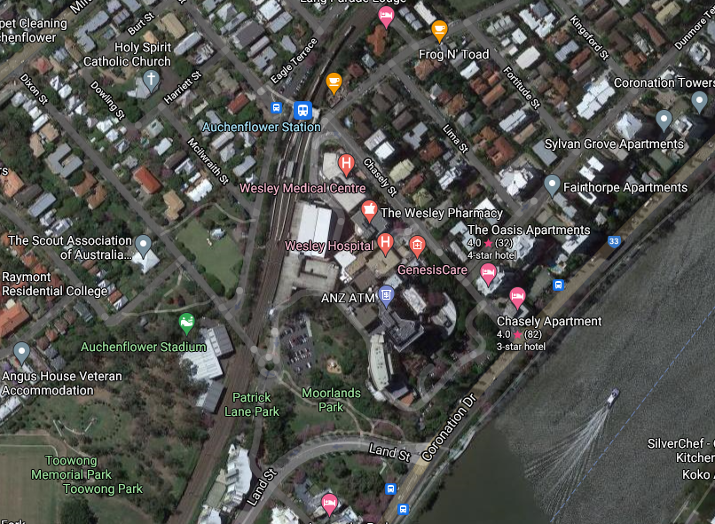

Lang Pde

Auchenflower Tce

Queensland Rail Limited ABN 71 132 181 090
Patrick Ln

Wesley Hospital carpark entry

Map data © Google, 2021

Access to The Wesley Hospital carpark

Lang Parade and Auchenflower Terrace

ROAD CLOSED

For more information, please contact the project’s community team on free call 1800 722 203 or email stationsupgrade@qr.com.au
Sign up for electronic notifications at queenslandrail.com.au/EmailNotification

