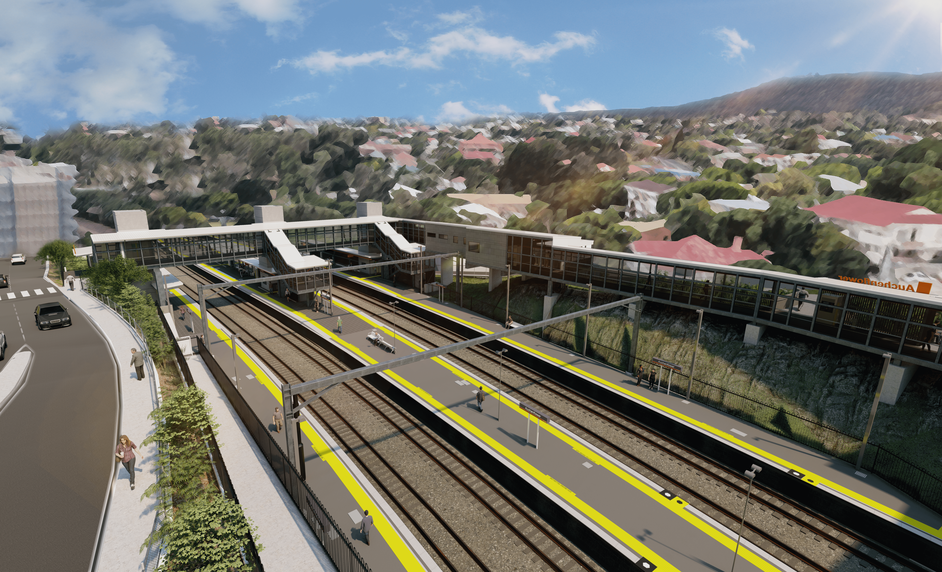
Auchenflower station accessibility upgrade

WORKS NOTICE

Night works – installation of site amenities
Wednesday 24 and Thursday 25 March 2021
As part of the Auchenflower station accessibility upgrade, Queensland Rail will deliver and install project amenities in the station carpark over two nights, on Wednesday 24 and Thursday 25 March, each night between 8pm and 5am the next day (weather and construction conditions permitting).
These works can only be undertaken after hours, when the carpark is free of customer vehicles and there are fewer members of the public around the station precinct.
Residents near the station may experience noise associated with excavation and the operation of project vehicles and equipment around the station carpark. Every effort will be made to minimise disruption and we thank you for your patience while we build you a better Auchenflower station.

Overview of works
Queensland Rail Limited ABN 71 132 181 090
Location | Dates and hours of work | Type of work
Auchenflower station carpark (off Eagle Terrace) | 8pm to 5am the next day on:  - Wednesday 24 March  - Thursday 25 March  (over two nights) | Delivery and installation of site amenities:  - operation of a vacuum excavator truck  - operation of franna crane, trucks and machinery with flashing lights and reversing beepers  - hand-held tools and powered equipment  - movement of personnel and vehicles around the station and in the rail corridor  - traffic control (to manage access to carpark, Eagle Terrace)  - portable lighting towers in use at night.
The Auchenflower station accessibility upgrade is part of the State Government’s ongoing investment of more than $500 million to upgrade stations across the South East Queensland network, making them accessible for all customers.
For more information, please contact the project’s community team on free call 1800 722 203 or email stationsupgrade@qr.com.au

