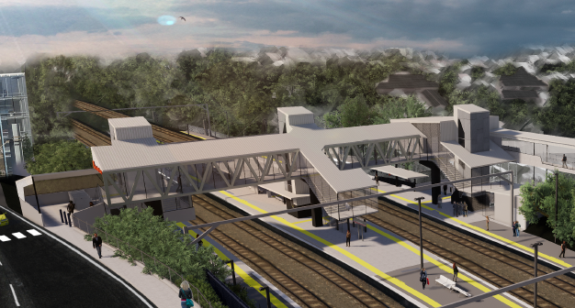
Auchenflower station accessibility upgrade

WORKS NOTICE

Upgrade early works (after hours)
November 2019

In preparation for the Auchenflower station accessibility upgrade, Queensland Rail will undertake early works after hours on selected dates in November, including around-the-clock works during a planned weekend track closure from 5am Saturday 9 to 10pm Sunday 10 November.
For customer and worker safety, these activities must be carried out after hours, when there is reduced rail traffic on the line. Works may be rescheduled in the event of adverse weather or construction conditions.
Nearby residents may experience noise associated with the use of jackhammers, foundation drilling and the operation of trucks and equipment around the work zone. Every effort will be made to minimise disruption and we apologise for any inconvenience as we undertake these important early works.

Overview of after hours works
Queensland Rail Limited ABN 71 132 181 090
Location | Dates and hours of work | Type of work
Auchenflower station  Station precinct and carpark  Lang Parade (lane closure)  Rail corridor including access gates (near Dixon Street and Eagle Terrace/Cue Street) | - Tuesday 5 to Friday 8 November, 9pm to 4.30am  (over 4 nights)  - 5am Saturday 9 to 10pm Sunday 10 November  (planned track closure – continuous, around-the-clock works)  - Monday 11 to Friday 15 November, 9pm to 4.30am  (over 5 nights, if/as required) | Activities involving:  - rock breaking using jackhammers and drilling foundations (Tuesday 5 to Friday 8 November)  - concrete pour (Saturday 9 and Sunday 10 November)  - site remediation and clean-up activities (Monday 11 to Friday 15 November, if/as required)  - operation of machinery and trucks with flashing lights and reversing beepers  - hand-held tools and powered equipment  - relocation of in-ground services  - movement of personnel and vehicles around the station and in the rail corridor  - lane closure with traffic management (Lang Parade and rail access gates)  - portable lighting towers in use at night.
The Auchenflower station accessibility upgrade is part of the State Government’s $357 million program to upgrade stations across the South East Queensland network, making them accessible for all customers.
For more information, please contact the project’s community team during business hours on free call 1800 722 203 or email stationsupgrade@qr.com.au

We are moving towards paperless notifications about noise and works. You will still see paper notices as we transition to the new system. Sign up at queenslandrail.com.au/EmailNotification or contact us if you prefer to receive paper copies.

