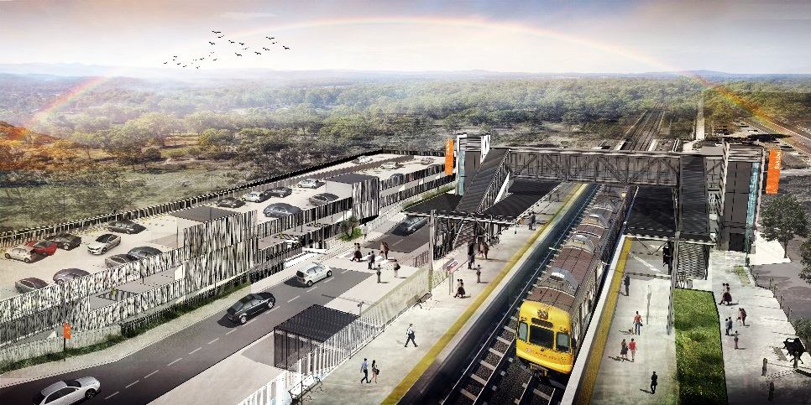
Dakabin station accessibility upgrade

WORKS NOTICE

Weekend and after hours works

August 2020

As part of the Dakabin station accessibility upgrade, Queensland Rail will undertake weekend and after hours works on selected dates in August. Weekend works are planned between 6.30am and 6.30pm each day on Saturday 15 and Sunday 16 and again on Saturday 22 and Sunday 23 August (weather and construction conditions permitting).
Activities include the on-site assembly of the station’s new footbridge, to be carried out in the small carpark area (currently closed) on the Narangba Road side of the station.
To meet critical works timeframes, it may be necessary to work over a period of nights from Monday 17 to Friday 28 August. These night works will only be undertaken if required.
Nearby residents may experience some noise associated with construction activities and the operation of vehicles and equipment.
Every effort will be made to minimise disruption and inconvenience as we work to improve your station.

Overview of after hours works
Location | Dates and hours of work | Type of work
Dakabin station precinct and adjacent rail corridor  Carpark (Narangba Road side) – closed | Weekend works:  6.30am to 6.30pm on:  - Saturday 15 August  - Sunday 16 August  - Saturday 22 August  - Sunday 23 August  (day works)  Night works (contingency):  6.30pm to 6.30am during:  - Monday 17 to Friday 28 August  (over 12 nights, only if required) | Footbridge assembly works involving:  Queensland Rail Limited ABN 71 132 181 090  - operation of cranes, heavy equipment and trucks with flashing lights and reversing beepers (cranes and lifting equipment – day works only)  - use of powered tools and hand-held equipment  - movement of personnel and vehicles around the station precinct and rail corridor.
Novel Coronavirus (COVID-19) – Queensland Rail is committed to keeping essential rail services operating for Queenslanders during this challenging time and to do this, network maintenance and critical capital works must continue. To support workforce safety, Queensland Rail has implemented a number of additional control measures related to COVID-19 management. We will continue to take the necessary precautions to ensure the ongoing health and wellbeing of our team and the communities in which we operate.
The Dakabin station accessibility upgrade is part of Queensland Rail’s $357 million investment to upgrade stations across the South East Queensland network, making them accessible for all customers.
For more information about the upgrade, please contact the project’s community team during business hours on 1800 722 203 (free call) or email stationsupgrade@qr.com.au

Sign up for paperless notifications at queenslandrail.com.au/EmailNotification

