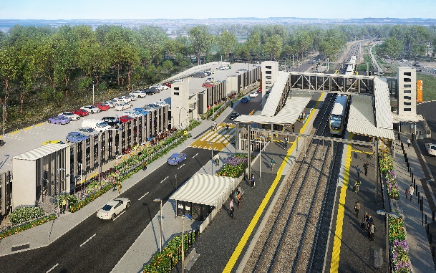
Dakabin station accessibility upgrade

WORKS NOTICE

After hours works – scheduled weekend track closure
March 2021
As part of the Dakabin station accessibility upgrade, Queensland Rail will undertake around-the-clock works from 11.30pm Friday 12 until 5am Monday 15 March (weather and construction conditions permitting).
Works will involve platform activities including paving, erection of shelter steelwork, installation of communications conduits and continued construction of the station’s new multi-storey carpark.
Residents near the station may experience some noise associated with construction activity and truck movements. Mobile lighting towers will be used during night works.
For the safety of workers and to maintain rail services, these works have been programmed during the scheduled weekend track closure of the Sunshine Coast/Caboolture line, when buses will replace trains.
The station footbridge (stair-only) will remain open to provide cross-corridor pedestrian access.
Every effort will be made to minimise disruption and inconvenience as we build you a better Dakabin station.
Queensland Rail Limited ABN 71 132 181 090

Scheduled works
Location | Dates and hours of work | Type of work
Dakabin station precinct (including carparks – closed)  Rail corridor  Footbridge – open | - 11.30pm Friday 12 to 5am Monday 15 March  (continuous works, during scheduled track closure) | Station upgrade and platform works involving:  - paving  - platform shelter steelwork  - installation of communications conduits under track  - operation of heavy machinery and trucks with flashing lights and reversing beepers  - use of hand-held tools and powered equipment  - movement of personnel and vehicles around the station precinct and rail corridor  - portable lighting in use at night.

The Dakabin station accessibility upgrade is part of the State Government’s investment of more than $500 million to upgrade stations across the South East Queensland network, making them accessible for all customers. For more information, please contact the project’s community team on free call 1800 722 203 or email stationsupgrade@qr.com.au

