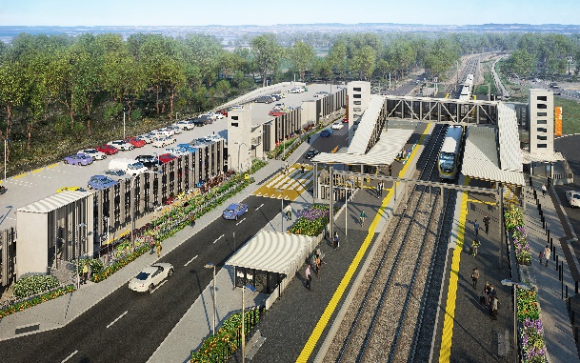
Dakabin station accessibility upgrade

WORKS NOTICE

Night and weekend works including timber footbridge removal

January 2021

As part of the Dakabin station accessibility upgrade, Queensland Rail will undertake weekend works on selected dates in January 2021 (weather and construction conditions permitting).
The station’s original timber footbridge will be removed overnight from 6pm Sunday 24 to 9am Monday 25 January 2021. The concrete staircase bases will be broken up on Monday morning using rock-breaking equipment. Station upgrade works will then continue during the scheduled weekend track closure on Saturday 30 and Sunday 31 January. For safety, these works must be undertaken after hours or during a track closure, when there is no rail traffic and the overhead power is switched off.
Residents near the station may experience some noise associated with construction activity and truck movements. Mobile lighting towers will be used during night works. Every effort will be made to minimise disruption and inconvenience as we build you a better Dakabin station.

Overview of works
Queensland Rail Limited ABN 71 132 181 090
Location | Dates and hours of work | Type of work
Dakabin station precinct and adjacent rail corridor  Footbridge (closed) | Timber bridge removal:  6pm Sunday 24 to 9am Monday 25 January  (overnight works)  Works during track closure:  8pm Friday 29 January to 5am Monday 1 February  (continuous works) | Station upgrade works (and footbridge removal) involving:  - large crane operation  - heavy machinery (including rock-breaking equipment) and trucks with flashing lights and reversing beepers  - platform works and paving  - hand-held tools and powered equipment (including saws)  - movement of personnel and vehicles around the station precinct  - portable lighting towers at night.

The Dakabin station accessibility upgrade is part of the State Government’s ongoing investment of more than $500 million to upgrade stations across the South East Queensland network, making them accessible for all customers. For more information, please contact the project’s community team on free call 1800 722 203 or email stationsupgrade@qr.com.au

