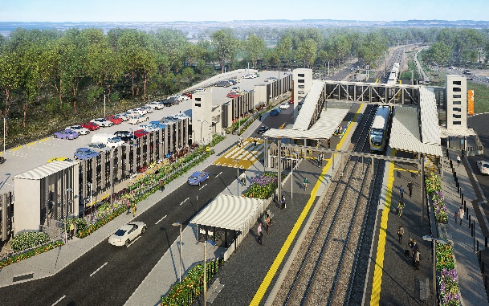
Dakabin station accessibility upgrade

WORKS NOTICE

After hours works – early morning concrete pours
April and May 2021
As part of the multi-storey carpark construction for Dakabin station accessibility upgrade, Queensland Rail is continuing to undertake a series of early concrete pours on selected mornings in April and May 2021.
The first early morning concrete pour will take place from 2am on Wednesday 28 April 2021. Subsequent morning concrete pours throughout May will be undertaken during regular working hours (after 6.30am), with the concrete truck arriving on-site from 6am on selected dates.
Note: These activities may be rescheduled, without further notice, due to weather or construction conditions.
Residents near the station may experience some noise associated with construction activity and truck movements. Mobile lighting towers will be used during night works. Every effort will be made to minimise disruption and inconvenience as we build you a better Dakabin station.

Overview of works
Queensland Rail Limited ABN 71 132 181 090
Location | Dates and hours of work | Type of work
Dakabin station precinct  Carpark work zone | From 2am on:  - Wednesday 28 April  Note: May concrete pours will be undertaken during regular daytime shifts (after 6.30am), with concrete trucks arriving on-site from 6am. | Station upgrade works and carpark concrete pours involving:  - operation of trucks (including concrete trucks) and machinery with flashing lights and reversing beepers  - operation of machinery including hand-held portable concrete vibrators  - movement of personnel and vehicles around the station precinct  - portable lighting towers at night.

The Dakabin station accessibility upgrade is part of the State Government’s ongoing investment of more than $500 million to upgrade stations across the South East Queensland network, making them accessible for all customers.
For more information, please contact the project’s community team on free call 1800 722 203 or email stationsupgrade@qr.com.au

