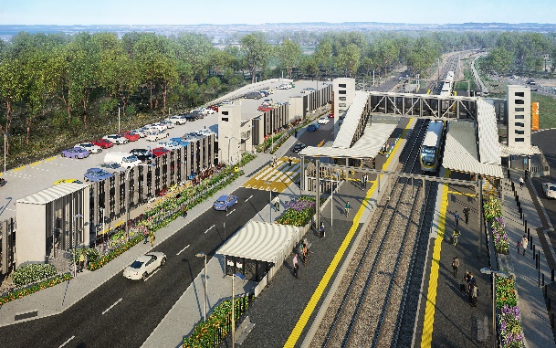
Dakabin station accessibility upgrade

WORKS NOTICE

After hours works – early morning concrete pours
January to March 2021

As part of the multi-storey carpark construction for Dakabin station accessibility upgrade, Queensland Rail is planning to undertake a series of out-of-hours concrete pours on selected mornings between January and March 2021.
Note: These activities may be rescheduled, without further notice, due to weather or construction conditions.
Residents near the station may experience some noise associated with construction activity and truck movements. Mobile lighting towers will be used during night works. Every effort will be made to minimise disruption and inconvenience as we build you a better Dakabin station.

Overview of works
Queensland Rail Limited ABN 71 132 181 090
Location | Dates and hours of work | Type of work
Dakabin station precinct  Carpark work zone | From 3am on the following dates:  - Tuesday 19 January  - Thursday 28 January  - Thursday 4 February  - Monday 8 February  - Wednesday 17 February  - Monday 22 February  - Friday 26 February  - Wednesday 3 March  - Monday 8 March  - Monday 15 March  - Thursday 18 March | Carpark concrete pour involving:  - operation of trucks (including concrete trucks) with flashing lights and reversing beepers  - operation of machinery including hand-held portable concrete vibrators  - movement of personnel and vehicles around the station precinct  - portable lighting towers at night.

The Dakabin station accessibility upgrade is part of the State Government’s ongoing investment of more than $500 million to upgrade stations across the South East Queensland network, making them accessible for all customers.
For more information, please contact the project’s community team on free call 1800 722 203 or email stationsupgrade@qr.com.au

