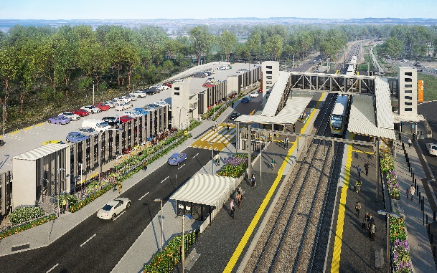
Dakabin station accessibility upgrade

WORKS NOTICE

Weekend (Sunday) works
November and December 2020

As part of the Dakabin station accessibility upgrade, Queensland Rail will undertake Sunday works throughout November and December 2020, 6.30am to 6.30pm (weather and construction conditions permitting). These Sunday shifts are in addition to the project’s regular working hours 6.30am to 6.30pm, Monday to Saturday.
Nearby residents may experience some noise associated with construction activities and the movement of project vehicles throughout the precinct.
Note: Services will not be affected except on Sunday 6 December, when trains will not stop at Dakabin station all weekend due to critical upgrade works. On the weekend of 5 and 6 December, a free shuttle bus will operate between Dakabin and Petrie stations to connect with all services (north and south). The station will operate as normal on all other Sundays listed on this notice.
Every effort will be made to minimise disruption and inconvenience as we build you a better Dakabin station.

Overview of Sunday works
Queensland Rail Limited ABN 71 132 181 090
Location | Dates and hours of work | Type of work
Dakabin station precinct and adjacent rail corridor | 6.30am to 6.30pm each day on:  - Sunday 22 November  - Sunday 29 November  - Sunday 6 December *  - Sunday 13 December  (day works only)  * Trains will not stop at Dakabin station on the weekend of 5 and 6 December. | Station upgrade/carpark construction involving:  - minor excavation and preparation of concrete footings  - column erection  - preparation of concrete slabs  - operation of heavy machinery and trucks with bright flashing lights and reversing beepers  - use of powered tools and hand-held equipment  - movement of personnel and vehicles around the station precinct and rail corridor.

The Dakabin station accessibility upgrade is part of the State Government’s investment to upgrade stations across the South East Queensland network, making them accessible for all customers.
For more information, please contact the project’s community team on free call 1800 722 203 or email stationsupgrade@qr.com.au

