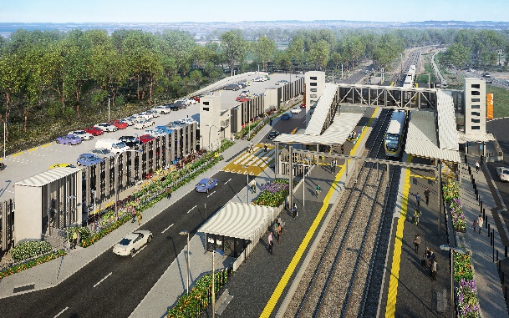
Dakabin station accessibility upgrade

WORKS NOTICE

Weekend (Sunday) works
Sunday 25 October and Sunday 1 November 2020

As part of the Dakabin station accessibility upgrade, Queensland Rail will undertake weekend works on Sunday 25 October and again on Sunday 1 November, 6.30am to 6.30pm (weather and construction conditions permitting). These Sunday shifts are in addition to the project’s regular working hours 6.30am to 6.30pm, Monday to Saturday.
Nearby residents may experience some noise associated with construction activities and the movement of project vehicles throughout the precinct.
Every effort will be made to minimise disruption and inconvenience as we build you a better Dakabin station.

Overview of weekend works
Location | Dates and hours of work | Type of work
Dakabin station precinct and adjacent rail corridor | 6.30am to 6.30pm each day on:  - Sunday 25 October  - Sunday 1 November  (day works only) | Station upgrade and carpark construction works involving:  Queensland Rail Limited ABN 71 132 181 090  - earthworks  - installation of foundations/footings  - concreting  - operation of excavators, heavy machinery, cranes and trucks with bright flashing lights and reversing beepers  - use of powered tools and hand-held equipment  - movement of personnel and vehicles around the station precinct and rail corridor.

The Dakabin station accessibility upgrade is part of Queensland Rail’s program to upgrade stations across the South East Queensland network, making them accessible for all customers.
For more information, please contact the project’s community team on free call 1800 722 203 or email stationsupgrade@qr.com.au

